Councillor guidance on how to access the Cyber and GDPR e-learning

Welcome to the ICT Critical User Service

Cyber and GDPR e-learning.

The council has provided an electronic training tool specifically designed for councillors that will guide you through 14 bite sized training modules covering GDPR, IT and Information Security based content such as Handling personal data, cyber awareness, how to spot scams or phishing attempts, physical hardware security and other important topics.

The training will provide you with valuable information and knowledge about Cyber security matters as well as key topics on GDPR, that will also be valuable outside of the council environment.

This short document will provide a step by step guide to accessing the e-learning.

- Initially, as part of an introductory e-mail, Councillors will each receive and email from Laura Powick in DSU introducing the e-learning, allowing you to register for the training.

Dear colleague. You’ll soon be receiving an email from Matobo Learning, inviting you to log in and verify your account on the Matobo Learning portal. The email looks like this:

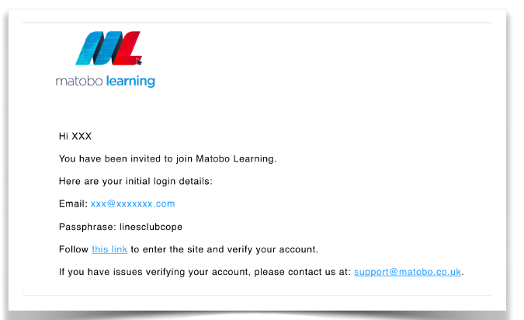

- Upon receipt of the e-mail, please follow the link and instructions, using the supplied passphrase. Once you’ve verified your account, the portal will require you to change the passphrase, using 3 random words to create a new passphrase (different to a password, as it’s technically complex but hopefully easier to remember!) You can refresh the 3 random words until you find a combination that you remember. At any time, if you forget your new passphrase, don’t worry - just select the “forgotten passphrase” option

- To access the e-learning from your council supplied i-Pad click on the icon called “Cyber Ninja”


- When you open it you will need to enter your username and password set earlier by yourself.
- Having logged on you may initially be presented with a landing page similar to the one shown below:

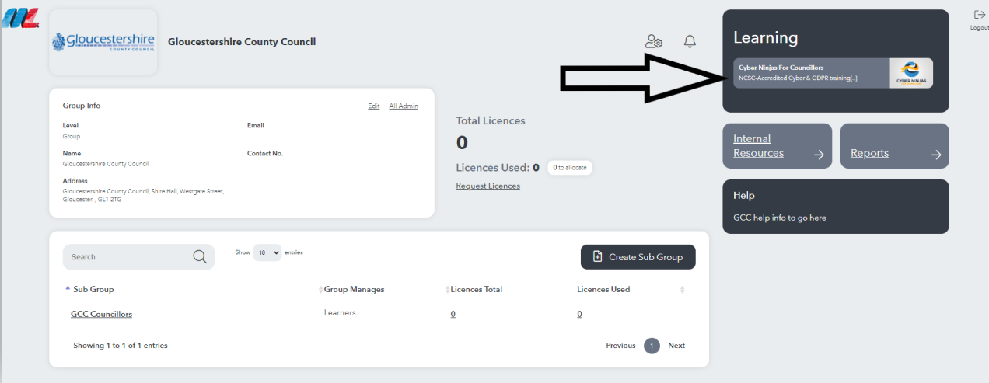

- Clicking on the Learning panel, as indicated by the black arrow above, will take you to the “Welcome to CN4C – Cyber Ninjas For Councillors” screen where you can access each of the 14 x training modules.
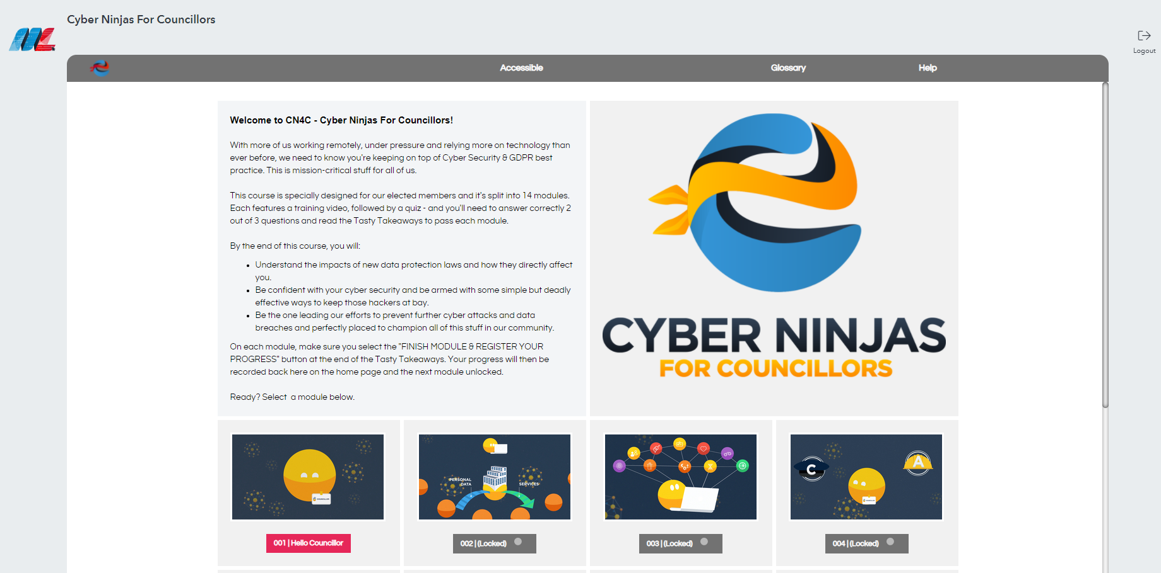

- Select each training module in turn and complete the training.
- Click on the play button to receive and engage with the interactive training.
- At the end of some of the training modules there will be a review of what you have learned:

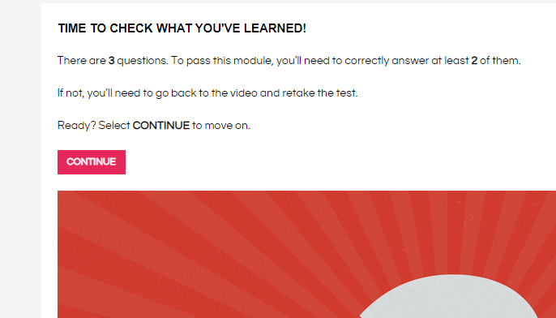

- Once you have registered completion of the training each module the screen will be updated as per the example below:
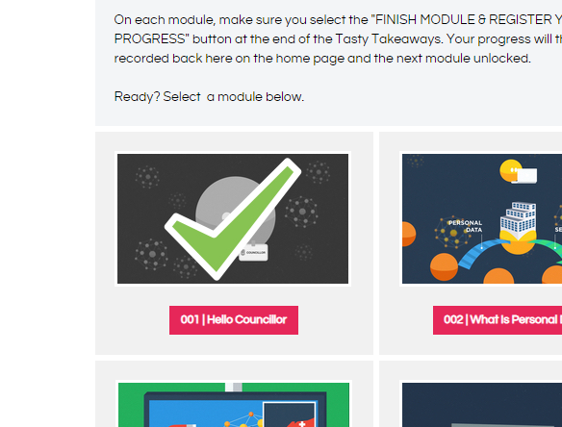
- To return to the dashboard or exit the training, please use the icons as shown below:

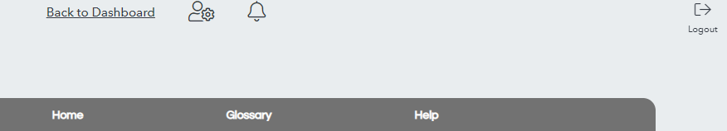
- Help and support can be obtained via the ICT Critical user service.

V1.1 Feb 22

