Assessment for Childcare Sufficiency

March 2018



Contents Page
SECTION 1: Children and Families 7
1. Demographic Information 7
1.1 Past: 2006 to 2016 7
1.2 Future: 2014 to 2039 Projections 7
1.3 Deprivation 8
1.3.1 Cheltenham Locality Area 8
1.3.2 Cotswold Locality Area 9
1.3.3 Forest of Dean Locality Area 9
1.3.4 Gloucester North Locality Area 10
1.3.5 Gloucester South Locality Area 10
1.3.6 Stroud Locality Area 11
1.3.7 Tewkesbury Locality Area 11
1.4 Household Income 12
1.5 Housing developments 13
1.6 BME Populations 13
1.7 Trends 14
1.8 Summary 14
SECTION 2: Current picture of childcare in Gloucestershire 15
2.1 Types of Childcare 15
2.2 Early Years Education: Supply 15
2.3 NEF Funding for 3 and 4 year olds 18
2.4 Help with Childcare Costs 19
2.5 Early Years National Funding Formula 20
2.6 Take up of 2, 3 and 4 year old childcare places 20
2.7 Stretched offer 21
2.8 Care for school age children 21
2.9 Quality 21
2.10 Workforce 22
2.11 Family Information Service 23
2.12 Business Support 23
3. Sufficiency of Early Education and Childcare by District and Children’s Centre Reach Area 24
3.1 Sufficiency, demand and gap analysis for Gloucester City 24
3.1.1 Profiles of demand and sufficiency by Children’s Centre Reach Area in Gloucester City 24
3.1.2 Gap Analysis of Gloucester City by Children Centre Reach Area 28
3.1.3 What the data tells us about Gloucester City Locality: 28
3.2 Sufficiency, demand and gap analysis for Cheltenham Locality 29
3.2.1 Sufficiency and demand by children’s centre reach area in the Cheltenham Locality 29
3.2.3 Gap Analysis of Cheltenham Locality by Children Centre Reach Area 32
3.2.4 What the data tells us about the Cheltenham Locality 32
3.3 Sufficiency, demand and gap analysis for Tewkesbury Locality 33
3.3.1 Sufficiency and demand by children’s centre reach area in the Tewkesbury Locality 33
3.3.2 Gap Analysis of Tewkesbury Locality by Children Centre Reach Area 35
3.3.3 What the data tells us about the Tewkesbury locality 35
3.4 Sufficiency, demand and gap analysis for Stroud Locality 37
3.4.1 Sufficiency and demand by children’s centre reach area in the Stroud Locality 37
3.4.2 Gap Analysis of Stroud Locality by Children Centre Reach Area 40
3.4.3 What the data tells us about the Stroud Locality 40
3.5 Sufficiency, demand and gap analysis for Forest of Dean Locality 41
3.5.1 Profiles of demand and sufficiency by Children’s Centre Reach Area in Forest of Dean Locality 41
3.5.2 Gap Analysis of Forest of Dean Locality by Children Centre Reach Area 43
3.5.3 What the data tells us about the Forest of Dean Locality 43
3.6 Sufficiency, demand and gap analysis for Cotswolds Locality 44
3.6.1 Profiles of demand and sufficiency by Children’s Centre Reach Area in Cotswold Locality 44
3.6.2 Gap Analysis of Cotswold Locality by Children Centre Reach Area 46
3.6.3 What the data tells us about the Cotswolds Locality 46
Appendices 47
Appendix 1: 30 hours free childcare parental survey results 47
Appendix 2: Childcare for children with Special Education Needs and Disabilities 52

Childcare Sufficiency Assessment 2018
Gloucestershire

The Childcare Sufficiency Assessment for Gloucestershire brings together a range of information that enables Gloucestershire County Council to understand the local childcare market. It is important for the local authority to know how the local market operates, the factors which influence the supply of and demand for services in order to manage and support the local market to meet its duty to ensure sufficient childcare.

The Childcare Act 2006 places duties on local authorities to improve outcomes for young children and reduce the inequalities between them; to secure sufficient childcare to enable parents to work; and to provide information to parents about childcare and a wide range of services that may benefit them.

It focuses in particular on sufficient, sustainable and flexible childcare that is responsive to parents’ requirements. This is to ensure that parents can find childcare locally that meets their needs enabling them to work or undertake education or training that could lead to work thereby increasing opportunities, choice and raising aspirations of families.

The Childcare Act 2006 defines childcare as ‘any form of care for a child‟ (other than healthcare) including education (other than that provided by schools during school hours) and any other ‘supervised activity‟. Childcare therefore includes the free 15 hour universal early education entitlement, but not formal education of children of statutory school age during the school day. This includes the provision of after school care for children up to the age of 15 and holiday play schemes.

The Childcare Act 2016 places a duty on local authorities from September 2017 to secure sufficient places for the extended free entitlement to 30 hours (which is an additional 15 hours a week on top of the universal entitlement for working parents of 3 and 4 year olds).

Through assessing the supply of and demand for childcare within Gloucestershire, gaps in provision will be identified. Plans can subsequently be developed to support the local market to address those gaps through the development of sustainable business opportunities with existing or new childcare providers.

Information gathered through the Childcare Sufficiency Assessment will also inform wider service planning, prioritisation in the changing political and economic climate and needs assessment for the Children and Young People’s Plan.

Gloucestershire Children Centre Areas

No | Children’s Centre Area | Geographical area
1 | Charlton Kings | Charlton Kings, Cheltenham
2 | Gardners Lane | Gardners Lane, Cheltenham
3 | Hesters Way | Hesters Way, Cheltenham
4 | Leckhampton | Leckhampton, Cheltenham
5 | Oakwood | Oakwood, Cheltenham
6 | Rowanfield | Rowanfield, Cheltenham
7 | Up Hatherley | Up Hatherley, Cheltenham
8 | Springboard – Cirencester | Cirencester, Cotswolds
9 | Springboard –Northleach/Fairford | Northleach/Fairford, Cotswolds
10 | Springboard – Stow | Stow, Cotswolds
11 | Springboard – Tetbury | Tetbury, Cotswolds
12 | Hilltop | Cinderford, Forest of Dean
13 | River | Lydney, Forest of Dean
14 | The Family Tree – Branches | Newent, Forest of Dean
15 | The Family Tree – Leaves | Coleford, Forest of Dean
16 | The Family Tree – Twigs | Mitcheldean, Forest of Dean
17 | Bartongate | Bartongate, Gloucester
18 | Finlay & Tredworth | Finlay & Tredworth, Gloucester
19 | Kaleidoscope – Elmbridge | Elmbridge, Gloucester
20 | Kaleidoscope – Kingsholm | Kingsholm, Gloucester
21 | Quedgeley | Quedgeley, Gloucester
22 | The Beacon | Kingsway, Gloucester
23 | The Compass | Coney Hill, Gloucester
24 | The Lighthouse | Gloucester, Gloucester
25 | The Link | Matson, Gloucester
26 | The Oaks | Tuffley, Gloucester
27 | Fiveways | Fiveways, Stroud
28 | Nailsworth | Nailsworth, Stroud
29 | Painswick | Painswick, Stroud
30 | Parliament | Stroud, Stroud
31 | The Park | Stonehouse, Stroud
32 | Treetops | Dursley, Stroud
33 | Wotton | Wotton under Edge, Stroud
34 | Bishops Cleeve | Bishops Cleeve, Tewkesbury
35 | Brockworth | Brockworth, Tewkesbury
36 | Jigsaw | Churchdown, Tewkesbury
37 | Noah’s Ark | Tewkesbury, Tewkesbury
38 | Northway & Ashchurch | Tewkesbury, Tewkesbury
39 | Winchcombe | Winchcombe, Tewkesbury

SECTION 1: Children and Families

1. Demographic Information
Between 2005 and 2015, the overall population growth in Gloucestershire has been driven mainly by internal movements. Natural growth, caused by higher numbers of births than deaths accounted for a growing proportion of the population in recent years and internal migration. The growth of the older population (65+) continued to outpace that of the younger generation.

1.1 Past: 2006 to 2016
Over the past ten years the number of 0-19 year olds in Gloucestershire has increased by 2526 children to 140,666 in 2016. This represents a 1.8% change compared to the national average of 5.1%. The proportion of 0-19 year olds as a proportion of the total population of the County decreased by 1.2% to 22.6% in 2016 which is in contrast to the national average 1.4% increase. In terms of the proportion of 0-19 year olds as a proportion of the total population in each district, Gloucester district has the highest at 25.0% amounting to 32,148 children and Cotswold district the lowest at 20.6% equating to 17,648 children.

Over the last ten years the population of 0-4 year olds in Gloucestershire rose by 15.6% to 35,109 children in 2016 which represents 5.6% of the total population.

The highest numbers of 0-4 year olds are located in Gloucester, Stroud and Cheltenham districts and reflect the general increase in births in those districts over the last few years.
Apart from Cotswold, the other five districts experienced growth between 2006 and 2016 with Gloucester district attaining the highest growth amounting to 29.0% (2,037 additional children) and Forest of Dean district the least growth of 5.8% (230 additional children) relating to a decline in births. Comparatively low numbers in Cotswold and Forest of Dean districts may also be indicative of a slight decrease in births over the last few years.

1.2 Future: 2014 to 2039 Projections
Assuming current population trends continue, the dominating feature of the projected trend is a sharp increase in the number of older people (65+) as a result of increased life expectancy and the demographic impacts of two generations of baby boomers which for Gloucestershire is higher than the national average. Projections for young children, young people and working-age people indicate only moderate growth and less than the English average.

The number of 0-19 year olds is predicted to rise to 148,173 by 2024 and to 153,435 in 2039. This represents an overall increase of 5262 children equivalent to an increase of 3.6%.

The 0-4 year olds are projected to maintain steady numbers reflecting a similar rate of births. The 5-9 year olds projections increase slightly before levelling off and maintaining steady numbers until 2039.

The 10-19 year olds are predicted to increase to 75,685 in 2024 followed by an increase to 79,908 in 2039.

1.3 Deprivation
The Indices of Deprivation 2015 are national measures based on 37 indicators, which highlight characteristics of deprivation such as unemployment, low income, crime and poor access to education and health services. The revised indices offer an in-depth approach to pinpointing small pockets of deprivation. Most indicators used data based on the tax year 2012/13. The indices are a key measure used by Central Government to help target policies and funding to improve the quality of life in disadvantaged communities. The headline measure is the Index of Multiple Deprivation.
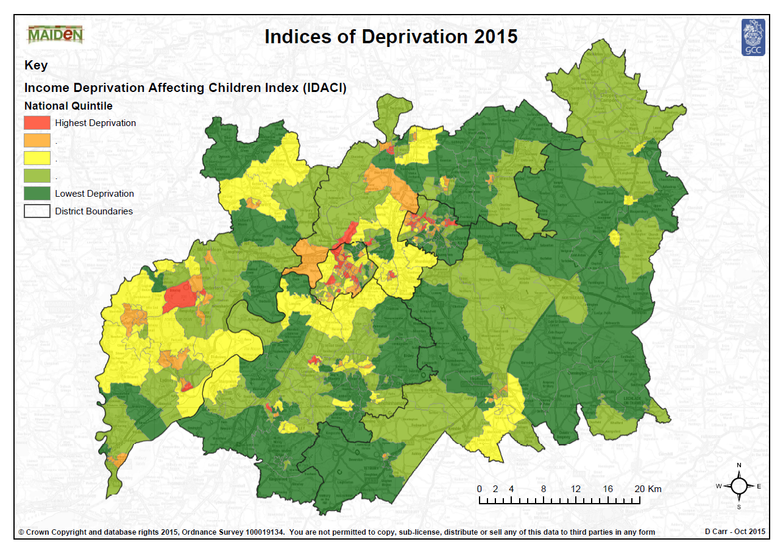
The indices use Lower Super Output Areas (LSOA) rather than wards. These are small geographical units averaging 1,500 people and provide a more in-depth appreciation of variations in deprivation at a local level.

1.3.1 Cheltenham Locality Area
Seven Children Centre Reach Areas are located in the Cheltenham Locality Area. Three of them namely Charlton Kings, Leckhampton and Up Hatherley relate to the areas of lowest deprivation and the remaining four are associated with areas of highest deprivation.
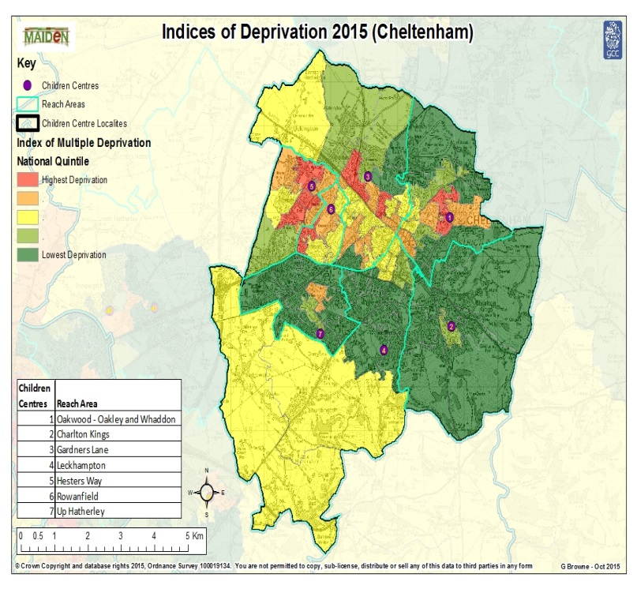

1.3.2 Cotswold Locality Area
There are four Children Centre Reach Areas in the Cotswold Locality Area. Apart from Cirencester, the other three reach areas, namely Northleach/Fairford, Stow and Tetbury are located in areas of lowest deprivation.
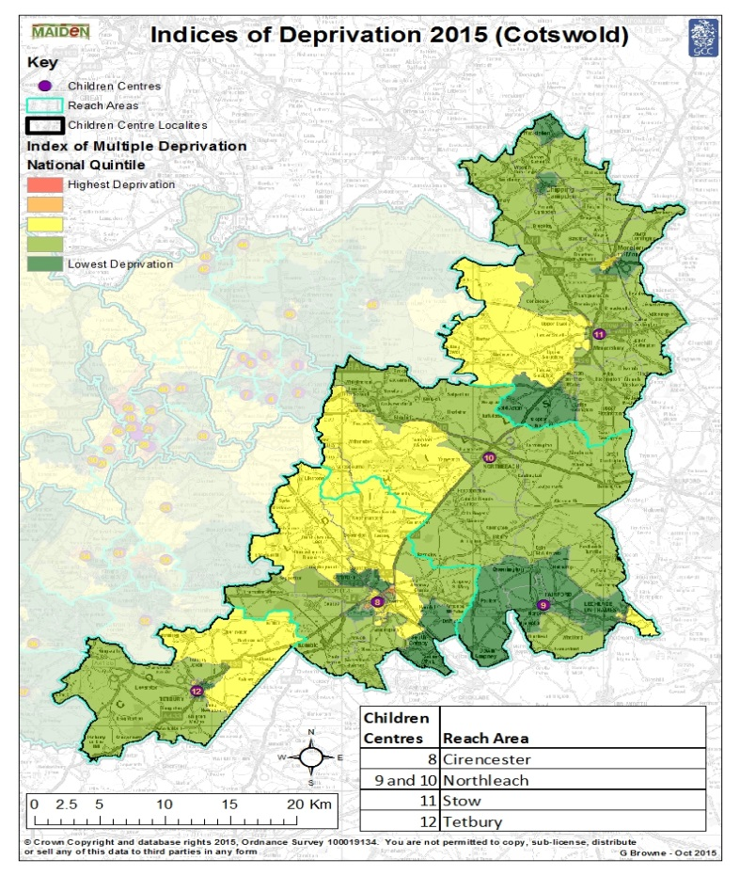

1.3.3 Forest of Dean Locality Area
There are five Children Centre Reach Areas located in the Forest of Dean Locality Area. All the reach areas portray an aspect of all five of the levels of deprivation although Twigs - Mitcheldean and Branches - Newent reach areas correspond to those areas of lowest deprivation while Hilltop reach area contains the only and relatively large area of high deprivation.
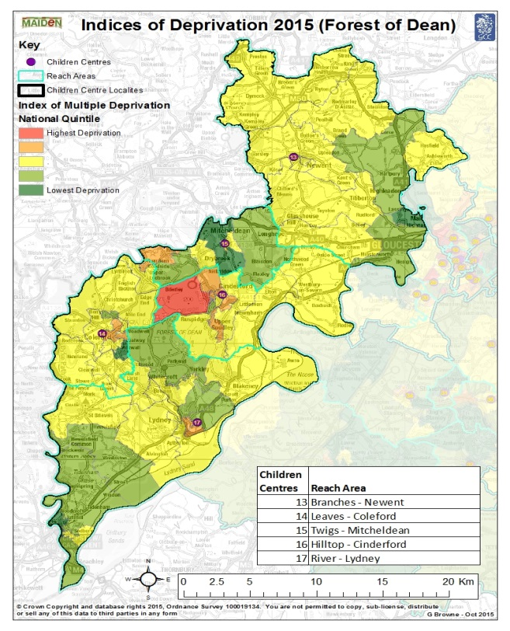

1.3.4 Gloucester North Locality Area
There are four Children Centre Reach Areas in the Gloucester North Locality Area. Apart from Elmbridge reach area they all coincide with the areas of highest deprivation.
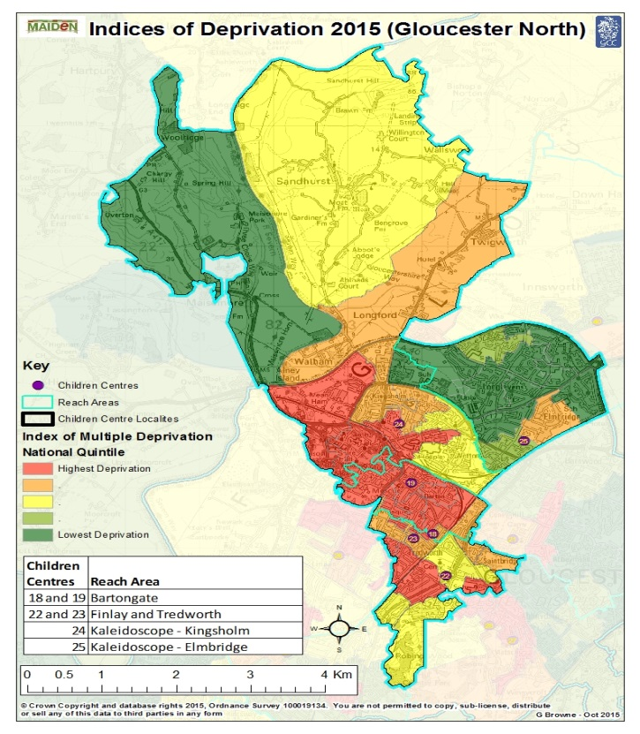

1.3.5 Gloucester South Locality Area
There are six Children Centre Reach Areas in the Gloucester South Locality Area. Quedgeley shows the least deprived area while The Link and The Lighthouse represents the areas with the highest deprivation.
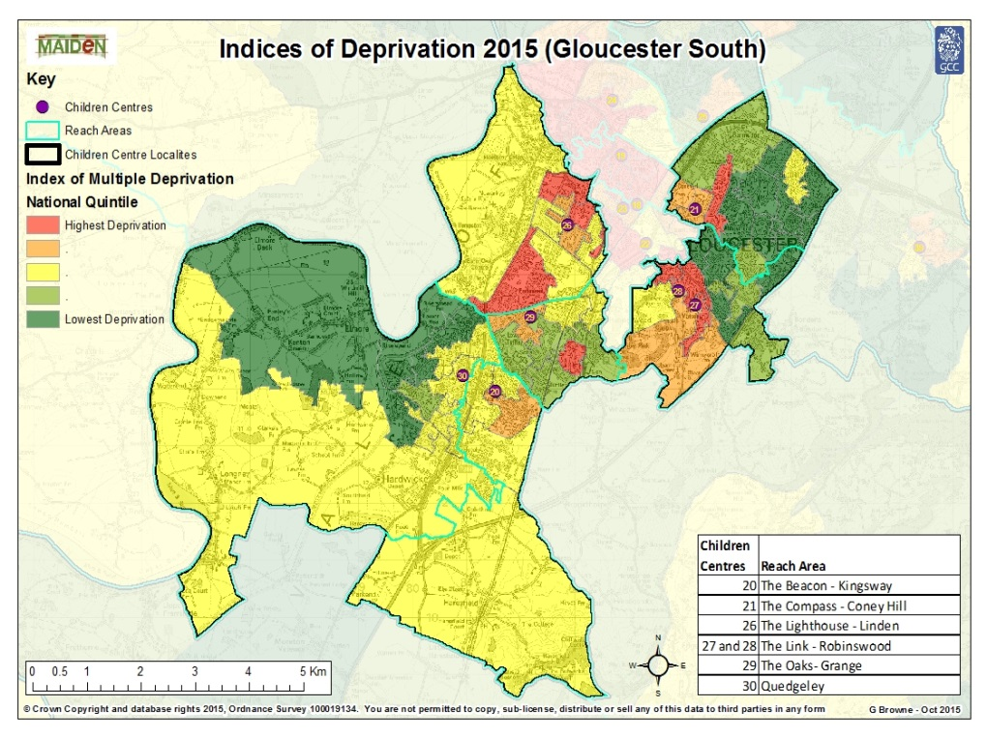

1.3.6 Stroud Locality Area
There are seven Children Centre Reach Areas in the Stroud Locality Area. Those localities representing higher levels of deprivation are small and diluted by the extent of the areas of lower deprivation.
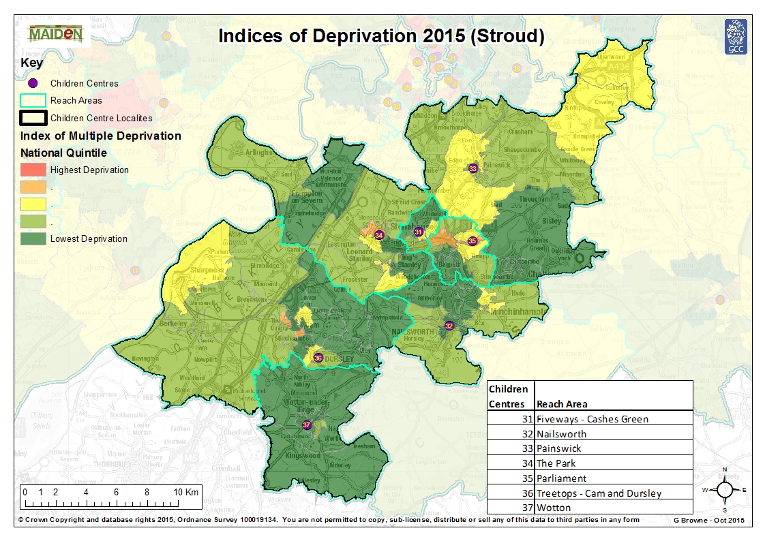

1.3.7 Tewkesbury Locality Area
There are six Children Centre Reach Areas in the Tewkesbury Locality Area. Bishops Cleeve and Winchcombe reach areas correspond to those areas of low deprivation and Noah’s Ark -Tewkesbury reach area represents a mix relating to higher deprivation.
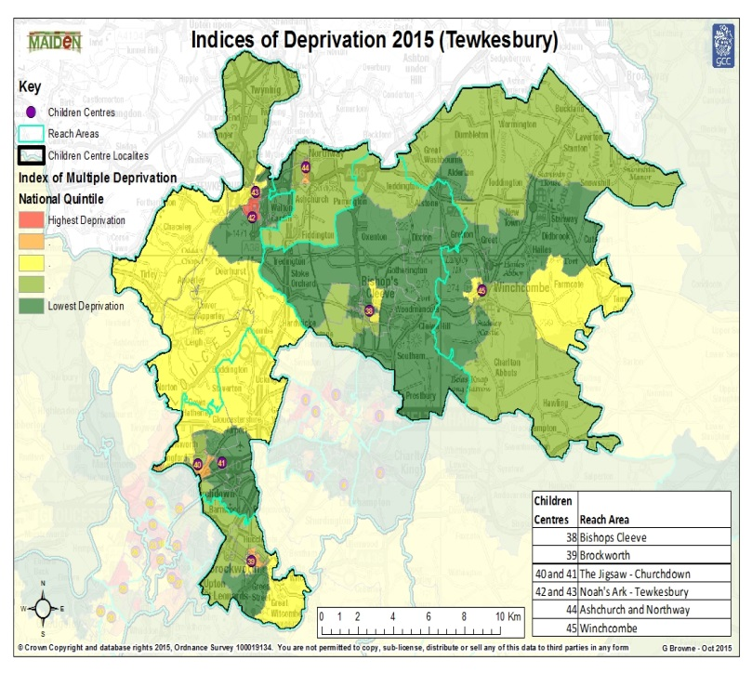

1.4 Household Income
Map 1 illustrates the location of where those households with a likely annual income of <£20,000 are located. Those LSOAs that are most likely to have a household income below £20,000 depicted by the pink shading tend to occur in the inner urban areas of Gloucester and Cheltenham, Cirencester and Tewkesbury. They are also located in the Cam and Stonehouse areas of Stroud district, around Cinderford, Lydney and Mitcheldean in the Forest of Dean district and Brockworth in Tewkesbury district.
Conversely, those LSOAs that are least likely to have a household income below £20,000 are indicated by the light blue shading on Map 1 and are located across much of the rural areas of Cotswold, Stroud and Tewkesbury districts.
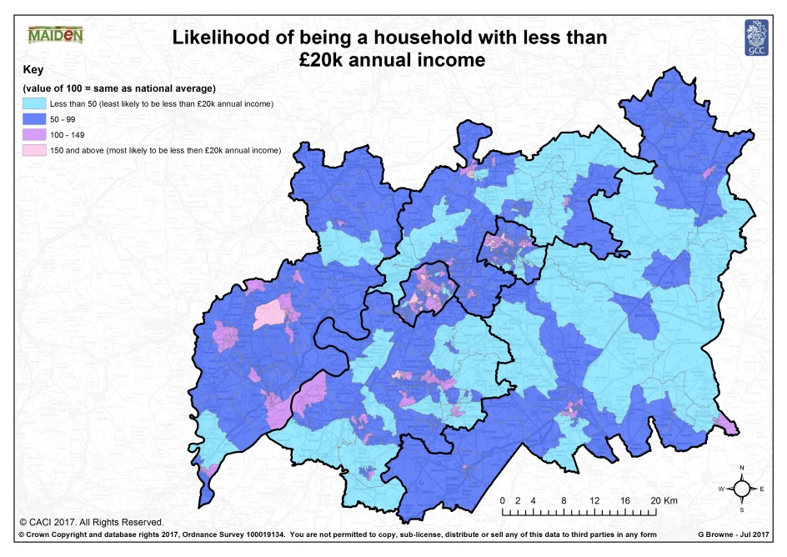

Map 2 shows where the likelihood of Households with more than £100,000 annual income are located. Not unsurprisingly this provides an almost reverse view to that shown by Map 1 in that those LSOAs which are most likely to have a household income of more than £100,000 represented by the pink shading are also located mainly in the rural areas of the Cotswold, Stroud and Tewkesbury districts.
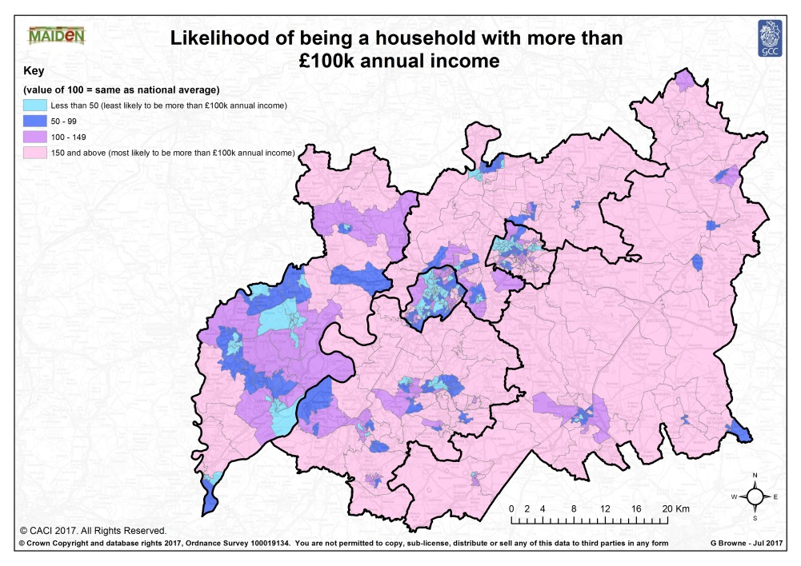

1.5 Housing developments
There are a number of large housing developments that are currently in development:

- Lydney – 1900 dwellings. Building is progressing and which will include a new school with a nursery on site.
- West of Stonehouse – 1350 dwellings. A new school will be built in this area with a nursery on site.
- North East Cam – 450 dwellings with possible further growth.
- Sharpness – 300 dwellings.
- Cheltenham – 4200 dwellings in the area of Swindon Village/Uckington which will include a new school with a nursery on site.
- Innsworth and Twigworth – up to 2025 dwellings. If these progress, new primary school with nursery on site will be provided.
- Chesterton – South of Cirencester – up to 2300 dwellings. A new primary school , and nursery provision will be provided.

The local authority works on all strategic sites to attempt to secure provision through s106 or other developer contributions (Community Infrastructure Levy).

1.6 BME Populations
At the time of the 2011 census the map shows that the areas that have a high BME population are Gloucester and Cheltenham. Some areas are more densely populated than others to 30% or more. The rest of the County has a fairly low BME population with the exception of Cirencester and Stroud, where some areas have a population of between 5.00% and 9.9%.
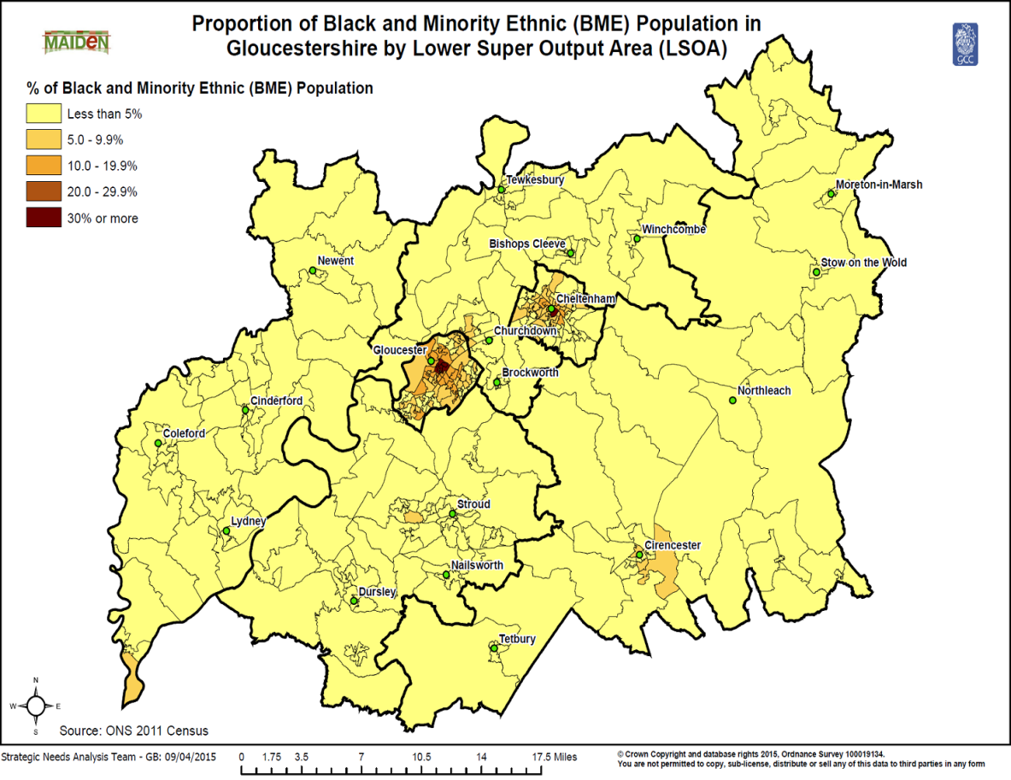

1.7 Trends
Although the proportion of children and young people is lower than the ageing population, birth rates are increasing. This trend is not reflected uniformly across the county and particular attention should therefore be paid to those areas identified where the largest house building projects are taking place. Such areas of new housing (particularly Affordable Housing) are likely to be attractive to young people of working age at the point of starting their families, with a consequent greater need for childcare.
The expansion of free childcare for 3 & 4 year olds from 15 hours universal entitlement to 30 hours extended entitlement for working parents from September 2017 will impact on childcare sufficiency across Gloucestershire. The Local Authority was successful in securing an amount of capital funding to increase capacity within a specific district of the County determined by the Department for Education.
The Government has introduced the Disability Access Fund (DAF) which provides additional funding to enable early years providers to anticipate and make reasonable adjustments to their provision, and should increase capacity to support disabled children and children with Special Educational Needs (SEN).

1.8 Summary
- Despite overall affluence there are significant pockets of deprivation in the county.
- Deprived neighbourhoods have higher levels of vulnerable children.
- Children subject to a range of statutory interventions are concentrated in Gloucester and Cheltenham.
- New housing developments will increase populations in Gloucester, Cheltenham, Forest of Dean, Stroud and the Cotswolds.
- 95% of the population describe themselves as ‘White –British’. The county’s small BME populations are concentrated in Gloucester and Cheltenham.

SECTION 2: Current picture of childcare in Gloucestershire

2.1 Types of Childcare
In Gloucestershire, the types of childcare include pre school (school managed), independent (school managed), day nurseries, playgroups, childminders, out of school clubs, holiday schemes and home carers.
The childminder sector is now offering significant free early education places within Gloucestershire. To enable parents to access childcare throughout the year, childminders and term time only providers work effectively in partnership to stretch their free early education entitlement.
As indicated in 1.5, where there is large housing growth within Gloucestershire and a new school is to be built, there will also be a new nursery on site.

2.2 Early Years Education: Supply
Free early years education is available for 40% of the county’s most vulnerable 2 year olds, and for 3 & 4 year olds it is a universal entitlement. The entitlement provides a maximum of 15 hours of free early education for 38 weeks a year until a child goes to school. From September 2017, the extended 30 hours free entitlement for 3 and 4 year olds of working parents will come into effect.

In April 2017 there were 506 settings claiming the 3 & 4 year old funding, 329 settings claiming the 2 year old entitlement and 514 settings planning on delivering the extended 30 hours entitlement.

(See Table of Care Scheme Type Totals by Children Centre Reach Area on next page.)

2.3 NEF Funding for 3 and 4 year olds
2 YEAR OLDS
TERMS | 2014/15 | 2015/16 | 2016/17 | 2017/18 Summer term
SUMMER
No of hours claimed | 163,464 | 256,314 | 238,016 | 216,363
% increase/decrease |  | 56.80% | -7.14% | -0.33%
No of 2 year olds | 1,102 | 1,696 | 1,538 | 1,484
Budget | £776,454 | £1,258,503 | £1,168,656 | £1,062,343
% increase/decrease |  | 62.08% | -7.14% | -0.33%
AUTUMN
No of hours claimed | 280,182 | 306,182 | 282,196
% increase/decrease |  | 9.28% | -7.83%
No of 2 year olds | 1,741 | 1,916 | 1,747
Budget | £1,330,863 | £1,503,352 | £1,385,582
% increase/decrease |  | 12.96% | -7.83%
SPRING
No of hours claimed | 245,492 | 231,563 | 213,745
% increase/decrease |  | -5.67% | -1.05%
No of 2 year olds | 1,744 | 1,622 | 1,697
Budget | £1,166,085 | £1,136,975 | £1,049,489
% increase/decrease |  | -2.50% | -1.05%
TOTAL
No of hours claimed | 689,137 | 794,059 | 733,957 | 216,363
% increase/decrease |  | 15.23% | -5.72% | -0.33% to date
No of 2 year olds | 4,587 | 5,234 | 4,982 | 1,484 to date
Budget | £3,273,402 | £3,898,830 | £3,603,728 | £1,062,343 to date
% increase/decrease

3 & 4 YEAR OLDS
TERMS | 2014/15 | 2015/16 | 2016/17 | 2017/18 Summer term
SUMMER
No of hours claimed | 1,860,253 | 1,859,244 | 1,911,204 | 1,812,035
% increase/decrease | 5.48% | -0.05% | 2.79% | 1.05%
No of 3 & 4 year olds | 12,628 | 12,798 | 13,012 | 11,645
Budget | £6,306,258 | £6,507,355 | £6,689,215 | £7,066,937
% increase/decrease | 10.03% | 3.19% | 2.79% | 7.78%
AUTUMN
No of hours claimed | 1,447,055 | 1,476,304 | 1,426,608
% increase/decrease | 1.91% | 2.02% | -3.37%
No of 3 & 4 year olds | 8,712 | 9,159 | 8,618
Budget | £4,905,515 | £5,167,065 | £4,993,130
% increase/decrease | 6.30% | 5.33% | -3.37%
SPRING
No of hours claimed | 1,602,239 | 1,640,889 | 1,600,576
% increase/decrease | 1.61% | 2.41% | -2.46%
No of 3 & 4 year olds | 11,258 | 11,271 | 10,941
Budget | £5,431,591 | £5,743,113 | £5,602,015
% increase/decrease | 5.99% | 5.74% | -2.46%
TOTAL
No of hours claimed | 4,909,547 | 4,976,438 | 4,938,388 | 1,812,035 to date
% increase/decrease | 1.32% | 1.36% | -0.76% | 1.05% to date
No of 3 & 4 year olds | 32,598 | 33,228 | 32,571 | 11,645 to date
Budget | £16,643,364 | £17,417,532 | £17,284,360 | £7,066,937 to date
% increase/decrease | 1.32% | 4.65% | -0.76% | 7.78% to date

2.4 Help with Childcare Costs
Current information to parents highlights several ways that they can get help with childcare costs:
- 2 year olds - for some families that meet the income or statutory criteria there are 570 hours per year free nursery education
- All pre-school children (3 & 4 years) receive the 570 hours from the term following their 3rd birthday
- For working families in England with pre-school children (3 & 4 years old) who meet the eligibility criteria, an extra 570 hours per year free nursery education can be claimed
- For working families, including the self employed in the UK with children under 12 (under 17 if disabled) may be able to access Tax-free Childcare. For every £8 paid, the Government will add an extra £2, up to £2,000 per annum per child
- Working families on low income may be able to claim up to 70% of childcare costs through the childcare element of the working tax credit
- For working families claiming Universal Credit with children under 16, they may be able to claim 85% of eligible childcare costs up to a cap
- Some parents with children under 16 (under 17 if disabled) may also be able to get help from their employer if they offer a childcare voucher scheme. Parents can get up to £933 a year in tax and national insurance savings
- There may be other forms of support for students such as ‘Care to Learn’ (for parents under the age of 20); Childcare Grant for full-time higher education students or discretionary learner support funds from colleges/learning providers.

2.5 Early Years National Funding Formula
The School Finance (England) Regulations 2012 (S.I.2012/335) set out how Local Authorities must operate their Early Years National Funding Formula (EYNFF). The regulations require that a Local Authority must consult their schools forum about and decide upon the funding formula which informs the hourly rate paid to providers.
A consultation was undertaken in January/February 2017 with all childcare providers in Gloucestershire as a result of the Department of Education (DfE) making changes to the way Early Years funding is distributed.
The results were taken to Schools Forum and the following changes came into effect on 1st April 2017:
- the 3 & 4 year old funding base rate is £3.90 per hour
- the hourly rate for eligible 2 year olds is £4.91 per hour
- a deprivation supplement is made for all eligible children. It is 4% of the total funding available, which equates to approximately 16p per hour
- as agreed by the sector after consultation, Gloucestershire County Council retains the quality supplement to fund work undertaken to support the Early Years sector. This is 0.5% of the total early years funding available and equates to 2p an hour

Rates and eligibility criteria are subject to change.
Support for settings to develop and operate sustainable business plans and models is available through National Day Nurseries Association (NDNA) who deliver this service under contract from the Children and Young People’s Directorate of Gloucestershire County Council until March 2018.

2.6 Take up of 2, 3 and 4 year old childcare places
Our Headcount data is available on a termly basis and is used by Gloucestershire County Council to establish which localities have a good take up and a poor take up of free childcare places. It identifies 2, 3 and 4 year olds by locality reach area and allows us to identify any gaps in provision.
In the Spring Term 2017, Gloucestershire funded 1318 two year olds to receive 15 hours of free early education over a maximum of 38 weeks. Providers can agree to stretch the offer over more than 38 weeks, as long as the hours claimed over the year are not more than 570.
Those providers that meet the national government eligibility quality criteria are able to be part of the scheme and receive funding to provide the entitlement for 2 year olds.

In the Spring Term 2017, Gloucestershire funded 10,081 three and four year olds to receive 15 hours of free early education over a maximum of 38 weeks. Providers can agree to stretch the offer over more than 38 weeks, as long as the hours claimed over the year are not more than 570.

2.7 Stretched offer
Early education funding for 2, 3 and 4 year olds can be used throughout the year (stretched). The entitlement for eligible 2 year olds and all 3 and 4 year olds under the universal entitlement is 570 hours per year which equates to either a maximum of 15 hours per week, over a maximum of 38 weeks or providers can agree to stretch the offer over more than 38 weeks, as long as the hours claimed over the year are not more than 570.
The entitlement for eligible 3 and 4 year olds of working parents under the extended 30 hour entitlement is 1140 hours (including the universal entitlement) per year which equates to either a maximum of 30 hours per week, over a maximum of 38 weeks or providers can agree to stretch the offer over more than 38 weeks, as long as the hours claimed over the year are not more than 1140.

2.8 Care for school age children
Although overall the number of providers has decreased since the last audit was undertaken in 2010, the biggest reduction has been within the childminding sector, this is both a national and a local trend.
Wrap around care is offered by some schools, this includes breakfast and after school clubs. The provision is in direct response to local community need, therefore not all schools have this service on site.

2.9 Quality
Ofsted is the organisation responsible for the registration and inspection of childcare for children 0-8. Following inspection, Ofsted makes a judgement on the quality of provision and specifies actions which providers must take to improve.

In addition to this the Early Years Team of GCC Children and Young People’s Directorate uses information to intervene where quality is a concern. The Early Years Team monitors and promotes ongoing improvement and quality within early years and childcare settings.

January 2016 | Category | January 2017
1136 | Number of providers | 1110
186 | Awaiting first inspection | 158
117 | On school inspection | 102
97 (11.6%) | Outstanding | 115 (13.5%)
585 (70.2%) | Good | 624 (73.4)
76 (9.1%) | Requires Improvement | 20 (2.4%)
1 (0.1%) | Inadequate | 7 (0.08%)
67 (8.0%) | Childcare register compliant | 75 (8.8%)
7 (0.8%) | Childcare register non compliant | 9 (1.1%)

The percentage of settings with ‘outstanding’ or ‘good’ Ofsted inspection outcomes increased by 5% between 2016 and 2017 to 86.9%. Similarly settings with ‘requires improvement’ inspection ratings fell 6.7% to 2.4%.

2.10 Workforce
Comparison of reported qualification levels between 2010 and 2016 of childcare staff.

Full day care, sessional care and creche settings

 | Qualified 2010 | Percentage | Qualified 2016* | Percentage
Level 1 | - | - | 9 | 0.3%
Level 2 | 477 | 19.5% | 473 | 15%
Level 3 | 1378 | 57% | 1937 | 61%
Level 4 | 141 | 6% | 164 | 5%
Level 5 | 118 | 5% | 161 | 5%
Level 6 | 175 | 7% | 399 | 12.7%
Level 7 | 12 | 0.5% | 39 | 1%
Total | 2424 | 100% | 3141 | 100%

There has been an increase in the workforce since 2010, and the levels of qualifications have increased significantly in most locality areas.

Childminders

 | Qualified 2010 | Percentage | Qualified 2016* | Percentage
Level 1 | 1 | 0.4% | 5 | 1.9%
Level 2 | 9 | 4% | 29 | 11%
Level 3 | 183 | 81% | 190 | 71.6%
Level 4 | 14 | 6.2% | 4 | 1.5%
Level 5 | 8 | 3.5% | 14 | 5.3%
Level 6 | 10 | 4.4% | 18 | 6.8%
Level 7 | 1 | 0.4% | 5 | 1.9%
Total | 226 | 100% | 265 | 100%

The data clearly demonstrates that between 2010 and 2016 there has been an increase in the qualification levels of childminders. In 2010, 36% of childminders held a full level 3 qualification and above, compared to 2016 where it was 87%.
Out of School

 | Out of School
Qualification level | 2016 Total* | %
Level 1 | 0 | 0%
Level 2 | 4 | 24%
Level 3 | 12 | 71%
Level 4 | 0 | 0%
Level 5 | 0 | 0%
Level 6 | 1 | 5%
Level 7 | 0 | 0%
Total | 17 | 100%

The data demonstrates 71% of the out of school sector hold a level 3 qualification or above in 2016, and 24% of the sector holds a Level 2 childcare qualification.
* All 2016 figures based on 3,423 workforce responses.

2.11 Family Information Service

The Family Information Service offers a wide range of information to support families, children and young people from 0 – 19 years old (25 for young people with additional needs). This includes information on finding and choosing childcare, funding support for children with special educational needs, helping parents with childcare entitlement queries etc.

The service also provides information on family support, benefits, tax credits, funding and much more. Enquiries are welcome by phone, email and letter and most are answered within one working day.

2.12 Business Support

The local authority currently has a contract with NDNA (National Day Nurseries Association) to provide a business support service for the early years and childcare sector in Gloucestershire. This sector includes provision in the voluntary, private and independent sector across day nurseries, playgroups, and schools.

The service provided includes business advice, support and training to develop sustainable, high quality childcare to ensure that the providers meet various legislative requirements.

3. Sufficiency of Early Education and Childcare by District and Children’s Centre Reach Area

3.1 Sufficiency, demand and gap analysis for Gloucester City

GLOUCESTER
Population of 2 year olds | 1858
Population of 3 year olds | 1916
Population of 4 year olds | 2024
Total population of 0-4 year olds | 9551
Total population of 5-11 year olds | 12618
Total number of places 0-5 (as at July 17) | 3555
Total number of providers for 0-5 year olds | 225
Number of providers offering 2 year old funded places | 150
Number of providers offering 3 & 4 year old universal entitlement (15 hours) | 157
Number of providers offering 3 & 4 year old extended entitlement (30 hours) | 130
Number of providers for school aged children | 26
% graded good or outstanding (excl Schools Ofsted & Awaiting inspection) | 87%
2 year old take up – Spring 2017 (children) | 521
3 & 4 year old take up -Spring 2017 (children) | 2596

3.1.1 Profiles of demand and sufficiency by Children’s Centre Reach Area in Gloucester City
Bartongate
Population of 2 year olds | 170
Population of 3 year olds | 172
Population of 4 year olds | 196
Total population of 0-4 year olds | 949
Total population of 5-11 year olds | 1193
Total number of places 0-5 (as at July 17) | 295
Total number of providers for 0-5 year olds | 15
Number of providers offering 2 year old funded places | 8
Number of providers offering 3 & 4 year old universal entitlement (15 hours) | 9
Number of providers offering 3 & 4 year old extended entitlement (30 hours) | 6
Number of providers for school aged children | 4
% graded good or outstanding (excl Schools Ofsted & Awaiting inspection) | 73
2 year old take up – Spring 2017 (children) | 92
3 & 4 year old take up -Spring 2017 (children) | 254

Finlay & Tredworth
Population of 2 year olds | 171
Population of 3 year olds | 147
Population of 4 year olds | 184
Total population of 0-4 year olds | 828
Total population of 5-11 year olds | 1258
Total number of places 0-5 (as at July 17) | 211
Total number of providers for 0-5 year olds | 16
Number of providers offering 2 year old funded places | 9
Number of providers offering 3 & 4 year old universal entitlement (15 hours) | 10
Number of providers offering 3 & 4 year old extended entitlement (30 hours) | 10
Number of providers for school aged children | 2
% graded good or outstanding (excl Schools Ofsted & Awaiting inspection) | 100
2 year old take up – Spring 2017 (children) | 42
3 & 4 year old take up -Spring 2017 (children) | 103

Kaleidoscope - Elmbridge
Population of 2 year olds | 159
Population of 3 year olds | 151
Population of 4 year olds | 176
Total population of 0-4 year olds | 764
Total population of 5-11 year olds | 1129
Total number of places 0-5 (as at July 17) | 481
Total number of providers for 0-5 year olds | 30
Number of providers offering 2 year old funded places | 22
Number of providers offering 3 & 4 year old universal entitlement (15 hours) | 23
Number of providers offering 3 & 4 year old extended entitlement (30 hours) | 21
Number of providers for school aged children | 5
% graded good or outstanding (excl Schools Ofsted & Awaiting inspection) | 100
2 year old take up – Spring 2017 (children) | 41
3 & 4 year old take up -Spring 2017 (children) | 326

Kaleidoscope - Kingsholm
Population of 2 year olds | 166
Population of 3 year olds | 123
Population of 4 year olds | 160
Total population of 0-4 year olds | 717
Total population of 5-11 year olds | 916
Total number of places 0-5 (as at July 17) | 391
Total number of providers for 0-5 year olds | 16
Number of providers offering 2 year old funded places | 9
Number of providers offering 3 & 4 year old universal entitlement (15 hours) | 10
Number of providers offering 3 & 4 year old extended entitlement (30 hours) | 9
Number of providers for school aged children | 3
% graded good or outstanding (excl Schools Ofsted & Awaiting inspection) | 100
2 year old take up – Spring 2017 (children) | 56
3 & 4 year old take up -Spring 2017 (children) | 293

Quedgeley
Population of 2 year olds | 262
Population of 3 year olds | 270
Population of 4 year olds | 270
Total population of 0-4 year olds | 1365
Total population of 5-11 year olds | 1595
Total number of places 0-5 (as at July 17) | 346
Total number of providers for 0-5 year olds | 28
Number of providers offering 2 year old funded places | 20
Number of providers offering 3 & 4 year old universal entitlement (15 hours) | 20
Number of providers offering 3 & 4 year old extended entitlement (30 hours) | 15
Number of providers for school aged children | 4
% graded good or outstanding (excl Schools Ofsted & Awaiting inspection) | 89
2 year old take up – Spring 2017 (children) | 43
3 & 4 year old take up -Spring 2017 (children) | 360

The Beacon
Population of 2 year olds | 191
Population of 3 year olds | 228
Population of 4 year olds | 209
Total population of 0-4 year olds | 1025
Total population of 5-11 year olds | 1180
Total number of places 0-5 (as at July 17) | 264
Total number of providers for 0-5 year olds | 18
Number of providers offering 2 year old funded places | 12
Number of providers offering 3 & 4 year old universal entitlement (15 hours) | 12
Number of providers offering 3 & 4 year old extended entitlement (30 hours) | 11
Number of providers for school aged children | 1
% graded good or outstanding (excl Schools Ofsted & Awaiting inspection) | 75
2 year old take up – Spring 2017 (children) | 50
3 & 4 year old take up -Spring 2017 (children) | 210

The Compass
Population of 2 year olds | 225
Population of 3 year olds | 239
Population of 4 year olds | 226
Total population of 0-4 year olds | 1109
Total population of 5-11 year olds | 1654
Total number of places 0-5 (as at July 17) | 464
Total number of providers for 0-5 year olds | 34
Number of providers offering 2 year old funded places | 19
Number of providers offering 3 & 4 year old universal entitlement (15 hours) | 21
Number of providers offering 3 & 4 year old extended entitlement (30 hours) | 16
Number of providers for school aged children | 3
% graded good or outstanding (excl Schools Ofsted & Awaiting inspection) | 85
2 year old take up – Spring 2017 (children) | 49
3 & 4 year old take up -Spring 2017 (children) | 302

The Lighthouse
Population of 2 year olds | 203
Population of 3 year olds | 244
Population of 4 year olds | 228
Total population of 0-4 year olds | 1129
Total population of 5-11 year olds | 1496
Total number of places 0-5 (as at July 17) | 532
Total number of providers for 0-5 year olds | 23
Number of providers offering 2 year old funded places | 19
Number of providers offering 3 & 4 year old universal entitlement (15 hours) | 19
Number of providers offering 3 & 4 year old extended entitlement (30 hours) | 15
Number of providers for school aged children | 2
% graded good or outstanding (excl Schools Ofsted & Awaiting inspection) | 100
2 year old take up – Spring 2017 (children) | 79
3 & 4 year old take up -Spring 2017 (children) | 314

The Link
Population of 2 year olds | 205
Population of 3 year olds | 222
Population of 4 year olds | 242
Total population of 0-4 year olds | 1086
Total population of 5-11 year olds | 1385
Total number of places 0-5 (as at July 17) | 340
Total number of providers for 0-5 year olds | 26
Number of providers offering 2 year old funded places | 18
Number of providers offering 3 & 4 year old universal entitlement (15 hours) | 19
Number of providers offering 3 & 4 year old extended entitlement (30 hours) | 15
Number of providers for school aged children | 0
% graded good or outstanding (excl Schools Ofsted & Awaiting inspection) | 75
2 year old take up – Spring 2017 (children) | 41
3 & 4 year old take up -Spring 2017 (children) | 258

The Oaks
Population of 2 year olds | 106
Population of 3 year olds | 120
Population of 4 year olds | 133
Total population of 0-4 year olds | 579
Total population of 5-11 year olds | 812
Total number of places 0-5 (as at July 17) | 231
Total number of providers for 0-5 year olds | 19
Number of providers offering 2 year old funded places | 14
Number of providers offering 3 & 4 year old universal entitlement (15 hours) | 14
Number of providers offering 3 & 4 year old extended entitlement (30 hours) | 12
Number of providers for school aged children | 2
% graded good or outstanding (excl Schools Ofsted & Awaiting inspection) | 76
2 year old take up – Spring 2017 (children) | 28
3 & 4 year old take up -Spring 2017 (children) | 176

3.1.2 Gap Analysis of Gloucester City by Children Centre Reach Area

3.1.3 What the data tells us about Gloucester City Locality:
- The % of setting rated good or outstanding by OFSTED is 87% across the Gloucester City area although the quality of provision is lower in Bartongate, The Beacon, The Compass, The Link and The Oaks.
- 58% of settings plan to offer the extended entitlement, more providers in Kingsholm – Elmbridge (70%) and The Lighthouse (65%) plan to offer 30 hours than other parts of the Gloucester City district.
- Take up of places for 2, 3 & 4 year olds is strong with higher take up for 2 year old places in Kingsholm – Elmbridge, The Compass and The Lighthouse.
- Take-up of places for 2, 3 & 4 year olds is particularly high in Kingsholm – Elmbridge.

3.2 Sufficiency, demand and gap analysis for Cheltenham Locality
CHELTENHAM
Population of 2 year olds | 1406
Population of 3 year olds | 1418
Population of 4 year olds | 1420
Total population of 0-4 year olds | 6920
Total population of 5-11 year olds | 9527
Total number of places 0-5 (as at July 17) | 3097
Total number of providers for 0-5 year olds | 191
Number of providers offering 2 year old funded places | 101
Number of providers offering 3 & 4 year old universal entitlement (15 hours) | 112
Number of providers offering 3 & 4 year old extended entitlement (30 hours) | 84
Number of providers for school aged children | 41
% graded good or outstanding (excl Schools Ofsted & Awaiting inspection) | 88%
2 year old take up – Spring 2017 (children) | 317
3 & 4 year old take up -Spring 2017 (children) | 2160

3.2.1 Sufficiency and demand by children’s centre reach area in the Cheltenham Locality
Charlton Kings
Population of 2 year olds | 117
Population of 3 year olds | 141
Population of 4 year olds | 128
Total population of 0-4 year olds | 602
Total population of 5-11 year olds | 1297
Total number of places 0-5 (as at July 17) | 316
Total number of providers for 0-5 year olds | 22
Number of providers offering 2 year old funded places | 8
Number of providers offering 3 & 4 year old universal entitlement (15 hours) | 12
Number of providers offering 3 & 4 year old extended entitlement (30 hours) | 9
Number of providers for school aged children | 5
% graded good or outstanding (excl Schools Ofsted & Awaiting inspection) | 78
2 year old take up – Spring 2017 (children) | 7
3 & 4 year old take up -Spring 2017 (children) | 241

Gardners Lane
Population of 2 year olds | 259
Population of 3 year olds | 269
Population of 4 year olds | 252
Total population of 0-4 year olds | 1341
Total population of 5-11 year olds | 1579
Total number of places 0-5 (as at July 17) | 719
Total number of providers for 0-5 year olds | 42
Number of providers offering 2 year old funded places | 22
Number of providers offering 3 & 4 year old universal entitlement (15 hours) | 22
Number of providers offering 3 & 4 year old extended entitlement (30 hours) | 20
Number of providers for school aged children | 11
% graded good or outstanding (excl Schools Ofsted & Awaiting inspection) | 86
2 year old take up – Spring 2017 (children) | 81
3 & 4 year old take up -Spring 2017 (children) | 464

Hesters Way
Population of 2 year olds | 222
Population of 3 year olds | 212
Population of 4 year olds | 255
Total population of 0-4 year olds | 1081
Total population of 5-11 year olds | 1411
Total number of places 0-5 (as at July 17) | 278
Total number of providers for 0-5 year olds | 23
Number of providers offering 2 year old funded places | 17
Number of providers offering 3 & 4 year old universal entitlement (15 hours) | 17
Number of providers offering 3 & 4 year old extended entitlement (30 hours) | 12
Number of providers for school aged children | 5
% graded good or outstanding (excl Schools Ofsted & Awaiting inspection) | 89
2 year old take up – Spring 2017 (children) | 95
3 & 4 year old take up -Spring 2017 (children) | 209

Leckhampton
Population of 2 year olds | 215
Population of 3 year olds | 219
Population of 4 year olds | 206
Total population of 0-4 year olds | 1047
Total population of 5-11 year olds | 1524
Total number of places 0-5 (as at July 17) | 520
Total number of providers for 0-5 year olds | 23
Number of providers offering 2 year old funded places | 10
Number of providers offering 3 & 4 year old universal entitlement (15 hours) | 13
Number of providers offering 3 & 4 year old extended entitlement (30 hours) | 11
Number of providers for school aged children | 5
% graded good or outstanding (excl Schools Ofsted & Awaiting inspection) | 84
2 year old take up – Spring 2017 (children) | 30
3 & 4 year old take up -Spring 2017 (children) | 401

Oakwood
Population of 2 year olds | 287
Population of 3 year olds | 260
Population of 4 year olds | 252
Total population of 0-4 year olds | 1284
Total population of 5-11 year olds | 1713
Total number of places 0-5 (as at July 17) | 672
Total number of providers for 0-5 year olds | 27
Number of providers offering 2 year old funded places | 16
Number of providers offering 3 & 4 year old universal entitlement (15 hours) | 17
Number of providers offering 3 & 4 year old extended entitlement (30 hours) | 10
Number of providers for school aged children | 6
% graded good or outstanding (excl Schools Ofsted & Awaiting inspection) | 91
2 year old take up – Spring 2017 (children) | 56
3 & 4 year old take up -Spring 2017 (children) | 394

Rowanfield
Population of 2 year olds | 113
Population of 3 year olds | 120
Population of 4 year olds | 122
Total population of 0-4 year olds | 612
Total population of 5-11 year olds | 677
Total number of places 0-5 (as at July 17) | 170
Total number of providers for 0-5 year olds | 13
Number of providers offering 2 year old funded places | 8
Number of providers offering 3 & 4 year old universal entitlement (15 hours) | 8
Number of providers offering 3 & 4 year old extended entitlement (30 hours) | 5
Number of providers for school aged children | 1
% graded good or outstanding (excl Schools Ofsted & Awaiting inspection) | 82
2 year old take up – Spring 2017 (children) | 28
3 & 4 year old take up -Spring 2017 (children) | 132

Up Hatherley
Population of 2 year olds | 193
Population of 3 year olds | 197
Population of 4 year olds | 205
Total population of 0-4 year olds | 953
Total population of 5-11 year olds | 1326
Total number of places 0-5 (as at July 17) | 422
Total number of providers for 0-5 year olds | 41
Number of providers offering 2 year old funded places | 20
Number of providers offering 3 & 4 year old universal entitlement (15 hours) | 23
Number of providers offering 3 & 4 year old extended entitlement (30 hours) | 17
Number of providers for school aged children | 8
% graded good or outstanding (excl Schools Ofsted & Awaiting inspection) | 100
2 year old take up – Spring 2017 (children) | 20
3 & 4 year old take up -Spring 2017 (children) | 319

3.2.3 Gap Analysis of Cheltenham Locality by Children Centre Reach Area

3.2.4 What the data tells us about the Cheltenham Locality
- The % of EY providers who are rated good or outstanding by OFSTED is 87% across the Cheltenham locality although the quality of provision is lower in Charlton Kings, Gardners Lane, Leckhampton and Rowanfield areas.
- Less than 50% of settings (48%) plan to offer the extended entitlement.
- Take up of 2, 3 & 4 year old places is high with higher take up for 2 year old places in Gardners Lane, Hesters Way and Leckhampton and higher take up for 3 & 4 year old places in Charlton Kings and Rowanfield.

3.3 Sufficiency, demand and gap analysis for Tewkesbury Locality
TEWKESBURY
Population of 2 year olds | 1010
Population of 3 year olds | 1001
Population of 4 year olds | 996
Total population of 0-4 year olds | 4878
Total population of 5-11 year olds | 6848
Total number of places 0-5 (as at July 17) | 2069
Total number of providers for 0-5 year olds | 160
Number of providers offering 2 year old funded places | 92
Number of providers offering 3 & 4 year old universal entitlement (15 hours) | 97
Number of providers offering 3 & 4 year old extended entitlement (30 hours) | 86
Number of providers for school aged children | 23
% graded good or outstanding (excl Schools Ofsted & Awaiting inspection) | 84%
2 year old take up – Spring 2017 (children) | 161
3 & 4 year old take up -Spring 2017 (children) | 1263

3.3.1 Sufficiency and demand by children’s centre reach area in the Tewkesbury Locality
Bishops Cleeve
Population of 2 year olds | 239
Population of 3 year olds | 225
Population of 4 year olds | 241
Total population of 0-4 year olds | 1103
Total population of 5-11 year olds | 1711
Total number of places 0-5 (as at July 17) | 501
Total number of providers for 0-5 year olds | 38
Number of providers offering 2 year old funded places | 23
Number of providers offering 3 & 4 year old universal entitlement (15 hours) | 24
Number of providers offering 3 & 4 year old extended entitlement (30 hours) | 20
Number of providers for school aged children | 4
% graded good or outstanding (excl Schools Ofsted & Awaiting inspection) | 68
2 year old take up – Spring 2017 (children) | 42
3 & 4 year old take up -Spring 2017 (children) | 288

Brockworth
Population of 2 year olds | 211
Population of 3 year olds | 197
Population of 4 year olds | 194
Total population of 0-4 year olds | 1004
Total population of 5-11 year olds | 1190
Total number of places 0-5 (as at July 17) | 402
Total number of providers for 0-5 year olds | 25
Number of providers offering 2 year old funded places | 12
Number of providers offering 3 & 4 year old universal entitlement (15 hours) | 13
Number of providers offering 3 & 4 year old extended entitlement (30 hours) | 12
Number of providers for school aged children | 4
% graded good or outstanding (excl Schools Ofsted & Awaiting inspection) | 74
2 year old take up – Spring 2017 (children) | 37
3 & 4 year old take up -Spring 2017 (children) | 256

Jigsaw
Population of 2 year olds | 218
Population of 3 year olds | 206
Population of 4 year olds | 200
Total population of 0-4 year olds | 1008
Total population of 5-11 year olds | 1288
Total number of places 0-5 (as at July 17) | 350
Total number of providers for 0-5 year olds | 31
Number of providers offering 2 year old funded places | 18
Number of providers offering 3 & 4 year old universal entitlement (15 hours) | 19
Number of providers offering 3 & 4 year old extended entitlement (30 hours) | 17
Number of providers for school aged children | 5
% graded good or outstanding (excl Schools Ofsted & Awaiting inspection) | 83
2 year old take up – Spring 2017 (children) | 38
3 & 4 year old take up -Spring 2017 (children) | 255

Noah's Ark
Population of 2 year olds | 169
Population of 3 year olds | 202
Population of 4 year olds | 204
Total population of 0-4 year olds | 949
Total population of 5-11 year olds | 1481
Total number of places 0-5 (as at July 17) | 384
Total number of providers for 0-5 year olds | 36
Number of providers offering 2 year old funded places | 22
Number of providers offering 3 & 4 year old universal entitlement (15 hours) | 22
Number of providers offering 3 & 4 year old extended entitlement (30 hours) | 19
Number of providers for school aged children | 5
% graded good or outstanding (excl Schools Ofsted & Awaiting inspection) | 90
2 year old take up – Spring 2017 (children) | 24
3 & 4 year old take up -Spring 2017 (children) | 238

Northway & Ashchurch
Population of 2 year olds | 99
Population of 3 year olds | 93
Population of 4 year olds | 73
Total population of 0-4 year olds | 435
Total population of 5-11 year olds | 580
Total number of places 0-5 (as at July 17) | 250
Total number of providers for 0-5 year olds | 19
Number of providers offering 2 year old funded places | 12
Number of providers offering 3 & 4 year old universal entitlement (15 hours) | 14
Number of providers offering 3 & 4 year old extended entitlement (30 hours) | 14
Number of providers for school aged children | 3
% graded good or outstanding (excl Schools Ofsted & Awaiting inspection) | 75
2 year old take up – Spring 2017 (children) | 18
3 & 4 year old take up -Spring 2017 (children) | 127

Winchcombe
Population of 2 year olds | 74
Population of 3 year olds | 78
Population of 4 year olds | 84
Total population of 0-4 year olds | 379
Total population of 5-11 year olds | 598
Total number of places 0-5 (as at July 17) | 182
Total number of providers for 0-5 year olds | 11
Number of providers offering 2 year old funded places | 5
Number of providers offering 3 & 4 year old universal entitlement (15 hours) | 5
Number of providers offering 3 & 4 year old extended entitlement (30 hours) | 4
Number of providers for school aged children | 2
% graded good or outstanding (excl Schools Ofsted & Awaiting inspection) | 89
2 year old take up – Spring 2017 (children) | 4
3 & 4 year old take up -Spring 2017 (children) | 99

3.3.2 Gap Analysis of Tewkesbury Locality by Children Centre Reach Area

3.3.3 What the data tells us about the Tewkesbury locality
- The % of setting rated good or outstanding by OFSTED is 84% across the Tewkesbury area although the quality of provision is lower in Brockworth, Northway and Ashchurch and Bishops Cleeve.
- 54% of settings plan to offer the extended entitlement, notably more providers in Northway and Ashchurch plan to offer 30 hours (74%) than other parts of the Tewkesbury district.
- Take up of places for 2, 3 & 4 year olds is generally good with higher take up for 2 year old places in Bishops Cleeve and Jigsaw.
- Sufficiency of places for 2, 3 & 4 year olds is strong in Northway and Ashchurch and Winchcombe.

3.4 Sufficiency, demand and gap analysis for Stroud Locality
STROUD
Population of 2 year olds | 1015
Population of 3 year olds | 1119
Population of 4 year olds | 1237
Total population of 0-4 year olds | 5377
Total population of 5-11 year olds | 8898
Total number of places 0-5 (as at July 17) | 2541
Total number of providers for 0-5 year olds | 191
Number of providers offering 2 year old funded places | 100
Number of providers offering 3 & 4 year old universal entitlement (15 hours) | 111
Number of providers offering 3 & 4 year old extended entitlement (30 hours) | 85
Number of providers for school aged children | 47
% graded good or outstanding (excl Schools Ofsted & Awaiting inspection) | 87%
2 year old take up – Spring 2017 (children) | 212
3 & 4 year old take up -Spring 2017 (children) | 1570

3.4.1 Sufficiency and demand by children’s centre reach area in the Stroud Locality
Fiveways
Population of 2 year olds | 107
Population of 3 year olds | 125
Population of 4 year olds | 149
Total population of 0-4 year olds | 637
Total population of 5-11 year olds | 980
Total number of places 0-5 (as at July 17) | 287
Total number of providers for 0-5 year olds | 20
Number of providers offering 2 year old funded places | 10
Number of providers offering 3 & 4 year old universal entitlement (15 hours) | 12
Number of providers offering 3 & 4 year old extended entitlement (30 hours) | 7
Number of providers for school aged children | 7
% graded good or outstanding (excl Schools Ofsted & Awaiting inspection) | 87
2 year old take up – Spring 2017 (children) | 26
3 & 4 year old take up -Spring 2017 (children) | 171

Nailsworth
Population of 2 year olds | 97
Population of 3 year olds | 141
Population of 4 year olds | 142
Total population of 0-4 year olds | 585
Total population of 5-11 year olds | 1086
Total number of places 0-5 (as at July 17) | 342
Total number of providers for 0-5 year olds | 23
Number of providers offering 2 year old funded places | 15
Number of providers offering 3 & 4 year old universal entitlement (15 hours) | 15
Number of providers offering 3 & 4 year old extended entitlement (30 hours) | 12
Number of providers for school aged children | 4
% graded good or outstanding (excl Schools Ofsted & Awaiting inspection) | 95
2 year old take up – Spring 2017 (children) | 20
3 & 4 year old take up -Spring 2017 (children) | 192

Painswick
Population of 2 year olds | 108
Population of 3 year olds | 137
Population of 4 year olds | 150
Total population of 0-4 year olds | 597
Total population of 5-11 year olds | 1255
Total number of places 0-5 (as at July 17) | 311
Total number of providers for 0-5 year olds | 33
Number of providers offering 2 year old funded places | 12
Number of providers offering 3 & 4 year old universal entitlement (15 hours) | 16
Number of providers offering 3 & 4 year old extended entitlement (30 hours) | 13
Number of providers for school aged children | 8
% graded good or outstanding (excl Schools Ofsted & Awaiting inspection) | 81
2 year old take up – Spring 2017 (children) | 16
3 & 4 year old take up -Spring 2017 (children) | 196

Parliament
Population of 2 year olds | 170
Population of 3 year olds | 182
Population of 4 year olds | 212
Total population of 0-4 year olds | 894
Total population of 5-11 year olds | 1460
Total number of places 0-5 (as at July 17) | 421
Total number of providers for 0-5 year olds | 25
Number of providers offering 2 year old funded places | 14
Number of providers offering 3 & 4 year old universal entitlement (15 hours) | 17
Number of providers offering 3 & 4 year old extended entitlement (30 hours) | 14
Number of providers for school aged children | 4
% graded good or outstanding (excl Schools Ofsted & Awaiting inspection) | 89
2 year old take up – Spring 2017 (children) | 42
3 & 4 year old take up -Spring 2017 (children) | 253

The Park
Population of 2 year olds | 203
Population of 3 year olds | 169
Population of 4 year olds | 225
Total population of 0-4 year olds | 914
Total population of 5-11 year olds | 1428
Total number of places 0-5 (as at July 17) | 461
Total number of providers for 0-5 year olds | 32
Number of providers offering 2 year old funded places | 13
Number of providers offering 3 & 4 year old universal entitlement (15 hours) | 15
Number of providers offering 3 & 4 year old extended entitlement (30 hours) | 12
Number of providers for school aged children | 14
% graded good or outstanding (excl Schools Ofsted & Awaiting inspection) | 87
2 year old take up – Spring 2017 (children) | 50
3 & 4 year old take up -Spring 2017 (children) | 289

Treetops
Population of 2 year olds | 266
Population of 3 year olds | 259
Population of 4 year olds | 270
Total population of 0-4 year olds | 1337
Total population of 5-11 year olds | 1973
Total number of places 0-5 (as at July 17) | 528
Total number of providers for 0-5 year olds | 41
Number of providers offering 2 year old funded places | 26
Number of providers offering 3 & 4 year old universal entitlement (15 hours) | 26
Number of providers offering 3 & 4 year old extended entitlement (30 hours) | 20
Number of providers for school aged children | 8
% graded good or outstanding (excl Schools Ofsted & Awaiting inspection) | 91
2 year old take up – Spring 2017 (children) | 50
3 & 4 year old take up -Spring 2017 (children) | 331

Wotton
Population of 2 year olds | 64
Population of 3 year olds | 106
Population of 4 year olds | 89
Total population of 0-4 year olds | 413
Total population of 5-11 year olds | 716
Total number of places 0-5 (as at July 17) | 191
Total number of providers for 0-5 year olds | 17
Number of providers offering 2 year old funded places | 10
Number of providers offering 3 & 4 year old universal entitlement (15 hours) | 10
Number of providers offering 3 & 4 year old extended entitlement (30 hours) | 7
Number of providers for school aged children | 2
% graded good or outstanding (excl Schools Ofsted & Awaiting inspection) | 73
2 year old take up – Spring 2017 (children) | 8
3 & 4 year old take up -Spring 2017 (children) | 138

3.4.2 Gap Analysis of Stroud Locality by Children Centre Reach Area

3.4.3 What the data tells us about the Stroud Locality
- The % of EY providers who are rated good or outstanding by OFSTED is 87% across the Stroud locality although the quality of provision is lower in Painswick and Wotton areas.
- Less than 50% of settings (44%) plan to offer the extended entitlement.
- Take up of 2, 3 & 4 year old places is reasonable with higher take up for 2 year old places in Fiveways, The Park and Wotton.
- Sufficiency of places for 2, 3 & 4 year olds is good. There is an above average demand for 2 year old places.

3.5 Sufficiency, demand and gap analysis for Forest of Dean Locality
FOREST OF DEAN
Population of 2 year olds | 845
Population of 3 year olds | 891
Population of 4 year olds | 943
Total population of 0-4 year olds | 4374
Total population of 5-11 year olds | 6639
Total number of places 0-5 (as at July 17) | 2149
Total number of providers for 0-5 year olds | 156
Number of providers offering 2 year old funded places | 88
Number of providers offering 3 & 4 year old universal entitlement (15 hours) | 92
Number of providers offering 3 & 4 year old extended entitlement (30 hours) | 79
Number of providers for school aged children | 32
% graded good or outstanding (excl Schools Ofsted & Awaiting inspection) | 87%
2 year old take up – Spring 2017 (children) | 235
3 & 4 year old take up -Spring 2017 (children) | 1328

3.5.1 Profiles of demand and sufficiency by Children’s Centre Reach Area in Forest of Dean Locality
Hilltop
Population of 2 year olds | 170
Population of 3 year olds | 166
Population of 4 year olds | 194
Total population of 0-4 year olds | 870
Total population of 5-11 year olds | 1253
Total number of places 0-5 (as at July 17) | 395
Total number of providers for 0-5 year olds | 29
Number of providers offering 2 year old funded places | 19
Number of providers offering 3 & 4 year old universal entitlement (15 hours) | 21
Number of providers offering 3 & 4 year old extended entitlement (30 hours) | 19
Number of providers for school aged children | 5
% graded good or outstanding (excl Schools Ofsted & Awaiting inspection) | 83
2 year old take up – Spring 2017 (children) | 44
3 & 4 year old take up -Spring 2017 (children) | 251

River
Population of 2 year olds | 284
Population of 3 year olds | 312
Population of 4 year olds | 308
Total population of 0-4 year olds | 1496
Total population of 5-11 year olds | 2113
Total number of places 0-5 (as at July 17) | 673
Total number of providers for 0-5 year olds | 49
Number of providers offering 2 year old funded places | 27
Number of providers offering 3 & 4 year old universal entitlement (15 hours) | 28
Number of providers offering 3 & 4 year old extended entitlement (30 hours) | 24
Number of providers for school aged children | 9
% graded good or outstanding (excl Schools Ofsted & Awaiting inspection) | 87
2 year old take up – Spring 2017 (children) | 82
3 & 4 year old take up -Spring 2017 (children) | 453

The Family Tree - Branches
Population of 2 year olds | 178
Population of 3 year olds | 166
Population of 4 year olds | 178
Total population of 0-4 year olds | 862
Total population of 5-11 year olds | 1249
Total number of places 0-5 (as at July 17) | 488
Total number of providers for 0-5 year olds | 38
Number of providers offering 2 year old funded places | 22
Number of providers offering 3 & 4 year old universal entitlement (15 hours) | 22
Number of providers offering 3 & 4 year old extended entitlement (30 hours) | 16
Number of providers for school aged children | 7
% graded good or outstanding (excl Schools Ofsted & Awaiting inspection) | 89
2 year old take up – Spring 2017 (children) | 26
3 & 4 year old take up -Spring 2017 (children) | 275

The Family Tree - Leaves
Population of 2 year olds | 125
Population of 3 year olds | 165
Population of 4 year olds | 170
Total population of 0-4 year olds | 734
Total population of 5-11 year olds | 1296
Total number of places 0-5 (as at July 17) | 353
Total number of providers for 0-5 year olds | 27
Number of providers offering 2 year old funded places | 13
Number of providers offering 3 & 4 year old universal entitlement (15 hours) | 13
Number of providers offering 3 & 4 year old extended entitlement (30 hours) | 11
Number of providers for school aged children | 8
% graded good or outstanding (excl Schools Ofsted & Awaiting inspection) | 85
2 year old take up – Spring 2017 (children) | 58
3 & 4 year old take up -Spring 2017 (children) | 233

The Family Tree - Twigs
Population of 2 year olds | 88
Population of 3 year olds | 82
Population of 4 year olds | 93
Total population of 0-4 year olds | 412
Total population of 5-11 year olds | 728
Total number of places 0-5 (as at July 17) | 240
Total number of providers for 0-5 year olds | 13
Number of providers offering 2 year old funded places | 7
Number of providers offering 3 & 4 year old universal entitlement (15 hours) | 8
Number of providers offering 3 & 4 year old extended entitlement (30 hours) | 9
Number of providers for school aged children | 3
% graded good or outstanding (excl Schools Ofsted & Awaiting inspection) | 100
2 year old take up – Spring 2017 (children) | 25
3 & 4 year old take up -Spring 2017 (children) | 116

3.5.2 Gap Analysis of Forest of Dean Locality by Children Centre Reach Area

3.5.3 What the data tells us about the Forest of Dean Locality
- The % of EY providers who are rated good or outstanding by OFSTED is 87% across the Forest of Dean locality although the quality of provision is lower in Hilltop and Leaves.
- 53% of settings plan to offer the extended entitlement.
- Take up of places for 2, 3 & 4 year olds is good with Twigs having notably higher than average take up for 2 and 3 & 4 year olds.
- Sufficiency of childcare places for 2, 3 & 4 year olds is good apart from Twigs and 2 year old places in Leaves.

3.6 Sufficiency, demand and gap analysis for Cotswolds Locality
COTSWOLDS
Population of 2 year olds | 810
Population of 3 year olds | 816
Population of 4 year olds | 862
Total population of 0-4 year olds | 3976
Total population of 5-11 year olds | 6388
Total number of places 0-5 (as at July 17) | 1907
Total number of providers for 0-5 year olds | 119
Number of providers offering 2 year old funded places | 66
Number of providers offering 3 & 4 year old universal entitlement (15 hours) | 75
Number of providers offering 3 & 4 year old extended entitlement (30 hours) | 59
Number of providers for school aged children | 26
% graded good or outstanding (excl Schools Ofsted & Awaiting inspection) | 92%
3 & 4 year old take up -Spring 2017 (children) | 1362

3.6.1 Profiles of demand and sufficiency by Children’s Centre Reach Area in Cotswold Locality
Springboard - Cirencester
Population of 2 year olds | 338
Population of 3 year olds | 325
Population of 4 year olds | 321
Total population of 0-4 year olds | 1575
Total population of 5-11 year olds | 2385
Total number of places 0-5 (as at July 17) | 686
Total number of providers for 0-5 year olds | 46
Number of providers offering 2 year old funded places | 26
Number of providers offering 3 & 4 year old universal entitlement (15 hours) | 30
Number of providers offering 3 & 4 year old extended entitlement (30 hours) | 25
Number of providers for school aged children | 9
% graded good or outstanding (excl Schools Ofsted & Awaiting inspection) | 93
2 year old take up – Spring 2017 (children) | 50
3 & 4 year old take up -Spring 2017 (children) | 643

Springboard - Northleach/Fairford
Population of 2 year olds | 184
Population of 3 year olds | 189
Population of 4 year olds | 213
Total population of 0-4 year olds | 907
Total population of 5-11 year olds | 1453
Total number of places 0-5 (as at July 17) | 369
Total number of providers for 0-5 year olds | 30
Number of providers offering 2 year old funded places | 17
Number of providers offering 3 & 4 year old universal entitlement (15 hours) | 19
Number of providers offering 3 & 4 year old extended entitlement (30 hours) | 11
Number of providers for school aged children | 6
% graded good or outstanding (excl Schools Ofsted & Awaiting inspection) | 88
2 year old take up – Spring 2017 (children) | 15
3 & 4 year old take up -Spring 2017 (children) | 292

Springboard - Stow
Population of 2 year olds | 201
Population of 3 year olds | 211
Population of 4 year olds | 212
Total population of 0-4 year olds | 1035
Total population of 5-11 year olds | 1851
Total number of places 0-5 (as at July 17) | 572
Total number of providers for 0-5 year olds | 29
Number of providers offering 2 year old funded places | 17
Number of providers offering 3 & 4 year old universal entitlement (15 hours) | 18
Number of providers offering 3 & 4 year old extended entitlement (30 hours) | 17
Number of providers for school aged children | 8
% graded good or outstanding (excl Schools Ofsted & Awaiting inspection) | 100
2 year old take up – Spring 2017 (children) | 19
3 & 4 year old take up -Spring 2017 (children) | 275

Springboard - Tetbury
Population of 2 year olds | 87
Population of 3 year olds | 91
Population of 4 year olds | 116
Total population of 0-4 year olds | 459
Total population of 5-11 year olds | 699
Total number of places 0-5 (as at July 17) | 280
Total number of providers for 0-5 year olds | 14
Number of providers offering 2 year old funded places | 6
Number of providers offering 3 & 4 year old universal entitlement (15 hours) | 8
Number of providers offering 3 & 4 year old extended entitlement (30 hours) | 6
Number of providers for school aged children | 3
% graded good or outstanding (excl Schools Ofsted & Awaiting inspection) | 85
2 year old take up – Spring 2017 (children) | 29
3 & 4 year old take up -Spring 2017 (children) | 152

3.6.2 Gap Analysis of Cotswold Locality by Children Centre Reach Area

3.6.3 What the data tells us about the Cotswolds Locality
- The % of setting rated good or outstanding by OFSTED is 92% across the Cotswolds area although the quality of provision is lower in Northleach & Fairford and Tetbury.
- 48% of settings plan to offer the extended entitlement.
- Take up of places for 2, 3 & 4 year olds is good (75%) with higher take up for 2,3 & 4 year old places in Cirencester but lower take up in Stow.

Appendices

Appendix 1: 30 hours free childcare parental survey results
Between 9th and 30th June 2017, Gloucestershire County Council ran a survey of parents to understand possible demand for the additional childcare entitlement (30 hours) from September 2017. The survey was promoted to parents via childcare providers, social media messaging, Gloucestershire County Council websites and intranet posts.
529 responses were received and responses were from parents of 622 children aged 1-4 in the Gloucestershire area. This report summarises the key results of the parental survey and has been produced for the Council and childcare providers. It is intended to give some indication of likely potential demand for the increased offer to help inform local sufficiency and business planning. Gloucestershire County Council will continue to monitor demand by running further parental surveys.
1. Responses
District | Responses
Cheltenham | 95
Cotswold | 70
Forest of Dean | 46
Gloucester | 115
Stroud | 88
Tewkesbury | 71
Could not be matched | 44
Grand Total | 529

The majority of respondents had a 3 year old child. 17% of respondents recorded having more than one child under 5.
District | Age 1 | Age 2 | Age 3 | Age 4
Cheltenham | 19 | 29 | 60 | 7
Cotswold | 8 | 33 | 31 | 9
Forest of Dean | 11 | 16 | 21 | 7
Gloucester | 30 | 39 | 54 | 14
Stroud | 17 | 27 | 48 | 12
Tewkesbury | 15 | 34 | 25 | 9
Unknown | 8 | 13 | 19 | 7
Grand Total | 108 (17%) | 191 (31%) | 258 (41%) | 65 (10%)
(Totals will not equal 529 due to families with more than one child)

2. Current demand for childcare by respondents of 3 and 4 year olds
The following graph shows the current use of childcare hours by respondents of 3 and 4 year old children (323 or 52% respondents to the survey.) 76% of respondents said they currently access some extra paid formal childcare in addition to the universal 15 hours free entitlement. 36.5% of respondents said they currently access 0 – 15 hours extra paid formal childcare and 39% said they accessed over 15 additional hours formal childcare. 41% of respondents said they used some informal childcare.

55% of respondents with 3 and 4 year old children access childcare during term time only. 31% of respondents access all year round childcare. Of those who thought they were eligible for the 30 hours and had children aged 3 or 4, 70% said they would wish to use childcare all year round rather than term time only.

37% of respondents with 3 and 4 year old children said they would use more than one provider to access 30 hours childcare.

3. Eligibility for 30 hours free childcare
467 or 88% of respondents thought they would be eligible for the 30 hours free childcare. The spread across the districts were:

Do you think you are eligible to claim the 30 hours free childcare? | No | Yes | Unknown | Grand Total | % Yes
Cheltenham | 11 | 82 | 2 | 95 | 86%
Cotswold | 7 | 62 | 1 | 70 | 89%
Forest of Dean | 4 | 42 |  | 46 | 91%
Gloucester | 7 | 106 | 2 | 115 | 92%
Stroud | 15 | 69 | 4 | 88 | 78%
Tewkesbury | 4 | 67 |  | 71 | 94%
Unknown | 3 | 39 | 2 | 44 | 89%
Grand Total | 51 | 467 | 11 | 529 | 88%

Of those who thought they would be eligible for the 30 hours free childcare, respondents had the following ages of children:

Do you think you are eligible to claim the 30 hours free childcare? | Age 1 | Age 2 | Age 3 | Age 4
Cheltenham | 16 | 23 | 55 | 5
Cotswold | 7 | 30 | 27 | 8
Forest of Dean | 11 | 16 | 19 | 4
Gloucester | 26 | 37 | 53 | 12
Stroud | 16 | 19 | 38 | 9
Tewkesbury | 14 | 32 | 24 | 8
Unknown | 7 | 13 | 19 | 5
% of respondents who thought they would be eligible with children of specific ages | 90% | 89% | 91% | 78%

Of those who thought they would be eligible for the 30 hours free childcare, 61% thought they would take up the full 30 hours:
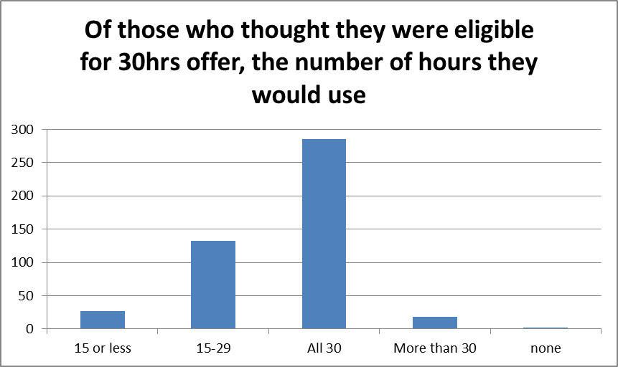

4. Demand for childcare
96% of respondents said they needed childcare 3 or more days a week.
The peak preferred start time was 8am and the peak preferred finish time given was 6pm, most respondents wanted childcare to start between 7 and 9am and finish between 3 and 6pm.
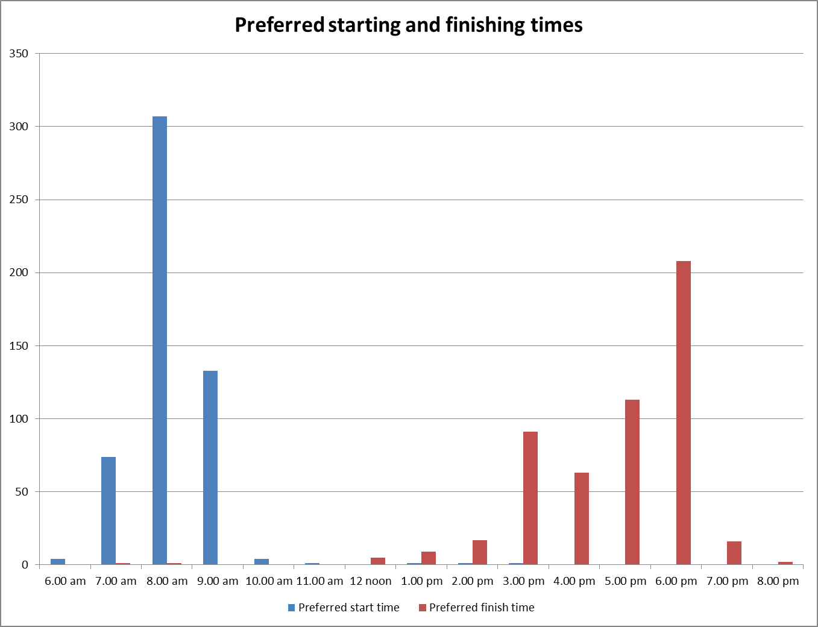
70% of respondents wanted childcare that was all year round. Of those who thought they were eligible for the 30 hours and had children aged 3 or 4, 70% also said they would wish to use childcare all year round rather than term time only.

Appendix 2: Childcare for children with Special Education Needs and Disabilities
SEND Audit 2017: Analysis of audit
The SEND Audit for Gloucestershire was initiated in the Summer Term of 2017. A link to the audit was sent via email to all early year’s settings including Childminders and Children’s Centres.
Context
In Gloucestershire there are currently 371 Daycare provisions and 439 Childminders. There are also 11 children’s centres none of which have early years provision. This gives a total of 810 early year’s settings altogether.
The total number of settings who completed the audit was 513, in comparison to 313 last year. This is a 63% response rate in comparison to 35% last year
Of those who responded, 296 were from a Daycare facility (57%), 208 were Childminders (40%) and 9 were from Children’s Centres (1%). There was also a small percentage that chose not to tell us who they were.
The county of Gloucestershire is broken down into seven localities, Cheltenham, Cotswolds, Forest of Dean, Gloucester North, Gloucester South, Stroud and Tewkesbury.
Cheltenham
Cheltenham has 68 Daycare Settings, 73 Childminder settings. This gives of total of 141 settings.
There were a total of 101 responses to the audit from Cheltenham settings (19%)
This response was broken down into:
- 62 Daycare settings, which is 16% of the total number of daycare settings
- 39 Childminder settings, which is 8% of the total number of Childminders.

Cotswolds
The Cotswolds has 49 Daycare Settings, 40 Childminder settings. This gives of total of 89 settings.
There were a total of 59 responses to the audit from Cotswold settings (11%)
This response was broken down into:
- 42 Daycare settings, which is 11% of the total number of daycare settings
- 17 Childminder settings, which is 3% of the total number of Childminders,

Forest
The Forest has 63 Daycare Settings, 52 Childminder settings. This gives of total of 115 settings.
There were a total of 72 responses to the audit from Forest settings (14%)
This response was broken down into:
- 48 Daycare settings, which is 12% of the total number of daycare settings
- 24 Childminder settings, which is 5% of the total number of Childminders,

Gloucester North
Gloucester North has 28 Daycare Settings, 34 Childminder settings. This gives of total of 62 settings.
There were a total of 51 responses to the audit from Gloucester North settings (9%)
This response was broken down into:
- 22 Daycare settings, which is 5% of the total number of daycare settings
- 29 Childminder settings, which is 6% of the total number of Childminders,

Gloucester South
Gloucester South has 43 Daycare Settings, 85 Childminder. This gives of total of 128 settings.
There were a total of 86 responses to the audit from Gloucester South settings (16%)
This response was broken down into:
- 46 Daycare settings, which is 12% of the total number of daycare settings
- 40 Childminder settings, which is 9% of the total number of Childminders,

Stroud
Stroud has 71 Daycare Settings, 68 Childminder settings. This gives of total of 139 settings.
There were a total of 84 responses to the audit from Stroud settings (16%)
This response was broken down into:
- 55 Daycare settings, which is 14% of the total number of daycare settings
- 29 Childminder settings, which is 6% of the total number of Childminders.

Tewksbury
Tewkesbury has 49 Daycare Settings, 87 Childminder setting. This gives of total of 136 settings.
There were a total of 63 responses to the audit from Tewkesbury settings (12%)
This response was broken down into:
- 29 Daycare settings, which is 10% of the total number of daycare settings
- 34 Childminder settings, which is 7% of the total number of Childminders.

Information gained from the Audit

Of the 63% of Gloucestershire’s settings who responded to the audit 57% said that they had been involved in writing a My Plan, 47% My Plan + , and 24% Education Health and Care (EHC) Plan and 55% of those said that they had been routinely involved in the monitoring and review process. 5% said that they were sometimes involved in the monitoring and review process and 36% did not respond to this question.

Of the 63% of Gloucestershire’s settings who responded to the audit 84% said that they had a setting SENCO. 70% said that their SENCO had attended training run by the local authority.

- The makeup of identified children
Of the 63% of Gloucestershire’s settings who responded to the audit 272 of the settings (53%) said that they had children in their setting whose development was causing them some concern.
242 (47%) of the settings who responded, said that they were caring for children identified as having a Special Educational Need and/or Disability (SEND)
234 (45%) of settings who responded, said that they make a record of those children identified as having SEND, and 227 (44%) said that they share these records with other people/agencies.

Of the 63% of Gloucestershire’s settings who responded to the audit and identified that they had children attending with SEND, 17% said that the children had a physical disability and 42% identified a learning disability. However 55% did not respond to this question.

The table below shows the number of settings who identified children with SEND in their setting in these age brackets

Under 1 | 1 – 1 yr 11m | 2 – 2yr 11m | 3 – 3yr 11m | 4 – 4yr 11m
5 | 14 | 89 | 106 | 138
Table 1 – number of settings who identified children in these age brackets

4 settings who responded to the audit said that they had been asked to support a child that they had been unable to include. 3 settings identified their physical environment as reasons for the exclusion.

- Training and Support
Of the 63% of Gloucestershire’s settings who responded to the audit:
474 (92%) of the people who responded said that they were aware of the Early Year’s Locality Advisers.
448 (87%) of the people who responded said that they were aware of the Early Help Advisers and
335 (65%) of the people who responded said that they were aware of SENCOSPOT.
487 (93%) of the people who responded said that they were aware of Glosfamilies Directory
146 (28%) of the settings who responded said that there were areas they felt they needed further support or advice with on caring for children with SEND
The areas identified were:

Training relating to children with SEND | 90
Support to develop practice to meet child’s needs and include them safely | 53
Support in considering additional support /resources | 57
Understanding the graduated pathway and completing paperwork | 64
Identifying which professionals need to be involved | 66
Other  Financial, medical, behaviour, regular visits from other agencies, terminology and clear signposting were all identified in this question. | 20
Table 2 – areas of support identified

The respondents were asked to identify how staff in the setting are kept up to date with SEND. The responses are tabulated below:

Training and skills are disseminated through the SENCO | 327
Staff attend internally run training courses | 149
Staff attend externally run training courses | 283
Staff are provided with guidance and training materials | 270
Training and skills are disseminated with other care settings | 88
Other | 53
Table 3 – how are other staff provided with opportunities to update their skills

- Meeting with other SENCOS

Of the 63% of Gloucestershire’s settings who responded to the audit 344 (67%) of settings said that they would benefit from meetings with other SENCOs on a regular basis.
148 (43%) said once per term would be the best frequency,
155 (45%) said twice per year would be the best frequency
38 (11%) said once per year would be the best frequency.
175 (50%) of the respondents said that Mon – Friday in the daytime would be the best time.
172 (50%) of the respondents said that Mon – Friday in the evening would be the best time and
74 (21%) said that Saturday morning would be the best time.

http://www.gloucestershire.gov.uk/inform/index.cfm?articleid=94727
https://inform.gloucestershire.gov.uk/viewpage.aspx?c=page&page=PopulationProjections
http://www.gloucestershire.gov.uk/inform/index.cfm?articleid=119821

