Census 2021 – First Release now published

On 28th June 2022 the Office for National Statistics (ONS) released the first results from the latest national Census which took place on 21st March 2021. These results give us a glimpse of how our local population has changed in the past decade.
“The census gives us the richest possible picture of society across England and Wales and is hugely important to inform decisions about all of our public services, from education to healthcare, and across the private sector. The results from this census will give us a crucial baseline from which to monitor and manage change as we emerge from the pandemic.” Deputy National Statistician Pete Benton.
Census 2021 first results includes five datasets containing population and household estimates for England and for Wales, rounded to the nearest 100, at local authority level. These are:
- usual resident population by sex
- usual resident population by 5-year age group
- usual resident population by sex and 5-year age group
- usual resident population density
- number of households

What do the results tell us about Gloucestershire?

The population of Gloucestershire
The usual resident population of Gloucestershire was 645,100 on Census Day, 21 March 2021. The population has increased by more than 48,000 (8.1%) compared with Census Day 2011, when there were 596,984 people in Gloucestershire. The rate of growth in Gloucestershire was higher than nationally, with the population of England and Wales increasing by 6.3% between 2011 and 2021.
The rate of population growth in Gloucestershire over the last decade has increased compared with the rate between 2001 and 2011, when the population grew by 5.7%. This differs from the picture seen nationally, with population growth in England and Wales decreasing slightly compared with the rate between 2001 and 2011, when the population grew by 7.8%.
Across Gloucestershire, population growth was greatest in Tewkesbury, with the population increasing by 15.8% from 2011 (a gain of approximately 13,000 people). As well as being the district with the highest growth in Gloucestershire, Tewkesbury has had one of the highest growth rates nationally, it was ranked 8th out of 331 district and unitary authorities in England and Wales and saw the greatest growth out of all authorities in the South West.
Cheltenham saw the smallest population growth in Gloucestershire, with the population increasing by 2.7% since 2011 (a gain of around 3,000 people). This puts Cheltenham in the bottom 25% of district and unitary authorities in England and Wales in terms of population growth. It also saw the second lowest population growth across authorities in the South West, with only the Isles of Scilly seeing a lower rate of growth.
Table 1: Population change 2011-2021
 | 2011 Population | 2021 Population | Net change 2011-2021 | % change 2011-2021
Cheltenham | 115,732 | 118,800 | 3,068 | 2.7%
Cotswold | 82,881 | 90,800 | 7,919 | 9.6%
Forest of Dean | 81,961 | 87,000 | 5,039 | 6.1%
Gloucester | 121,688 | 132,500 | 10,812 | 8.9%
Stroud | 112,779 | 121,100 | 8,321 | 7.4%
Tewkesbury | 81,943 | 94,900 | 12,957 | 15.8%
Gloucestershire | 596,984 | 645,100 | 48,116 | 8.1%
South West | 5,288,935 | 5,701,200 | 412,265 | 7.8%
England | 53,012,456 | 56,489,800 | 3,477,344 | 6.6%
England and Wales | 56,075,912 | 59,597,300 | 3,521,388 | 6.3%

Sex and Age Structure of Gloucestershire
Gloucestershire’s female population continues to be greater than the male population, equivalent to a difference of approximately 14,500 more females and a 51.1% to 48.9% female to male distribution. This echoes the regional and national trend.
The working-age population (aged 15-64) increased by 3.4% (a gain of around 6,400 people) on Census Day 2021 compared to Census Day 2011. In comparison, the population aged 0-14 increased by 6.5% (a gain of around 13,100 people) and the 65+ population increased by 25.6% (a gain of around 28,500 people).
Figure 1 displays Gloucestershire’s population by sex and 5-year age groups. It also compares the 2021 Census Day population to the 2011 Census Day population. The key changes in age structure between 2011 and 2021 are:
- The biggest decrease was in 40-44 year olds for both males and females (-16.2% and -12.7%)
- There has been a decrease in 15-19 year olds and 20-24 year olds (-6.8% and -4.2%)
- There has been a decrease in the number of 0-4 year olds (-3.4%)
- All 5-year age groups over 50 years increased, with the biggest being by 70-74 year olds (44.5%)
- There has been an increase in people between the ages of 25-39
- The has been an increase in children aged 5-9 (14.8%) and 10-14 (8.5%)

Figure 1: Population Pyramid for Gloucestershire, Census 2011 and 2021
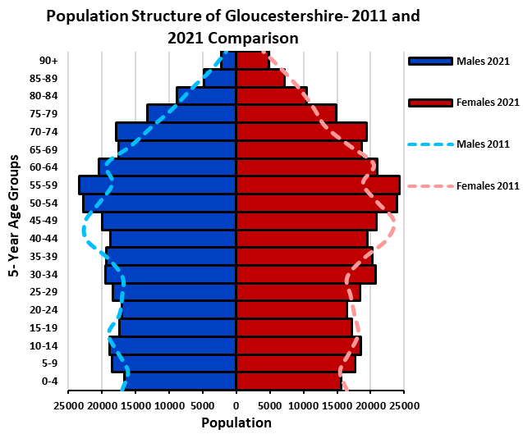

Population density
There were 243 residents per square kilometre in Gloucestershire in 2021. It compares with 395 residents per square kilometre in England and Wales.
Population density varies across the county. The urban districts of Cheltenham and Gloucester have densities of 2,550 and 3,267 residents per square kilometre respectively. In contrast, Cotswold district has a density of 78 residents per square kilometre.

Households in Gloucestershire
There were 279,400 households in Gloucestershire on Census Day. This was a 9.7% increase (around 25,000 more households) on the 254,615 households in 2011. Across England and Wales the number of households grew at a slightly lower rate of 6.1%.
Mirroring the trend with the changes in population size, Tewkesbury saw the greatest growth in households since 2011, with a growth of 16.4%, this places it 4th amongst the 331 district and unitary authorities in the England and Wales. Cheltenham saw the smallest growth in households across Gloucestershire, with a growth of 3.9%, placing it 242 out of the 331 district and unitary authorities.

Table 2: Change in the number of households, 2011-2021
 | 2011 Households | 2021 Households | Net change 2011-2021 | % change 2011-2021
Cheltenham | 50,929 | 52,900 | 1,971 | 3.9%
Cotswold | 36,236 | 40,600 | 4,364 | 12.0%
Forest of Dean | 34,167 | 37,200 | 3,033 | 8.9%
Gloucester | 50,363 | 55,400 | 5,037 | 10.0%
Stroud | 47,794 | 52,400 | 4,606 | 9.6%
Tewkesbury | 35,126 | 40,900 | 5,774 | 16.4%
Gloucestershire | 254,615 | 279,400 | 24,785 | 9.7%
South West | 2,264,641 | 2,448,800 | 184,159 | 8.1%
England | 22,063,368 | 23,435,700 | 1,372,332 | 6.2%
England and Wales | 23,366,044 | 24,782,800 | 1,416,756 | 6.1%

What’s next?
Following the first release in June, the ONS will release further results from the census from the autumn onwards. These will include data on ethnicity, religion, the labour market, education and housing. For the first time, it will also include information on armed forces veterans, sexual orientation and gender identity.
As this information is released it will be made available here: https://www.gloucestershire.gov.uk/inform/population/census-of-population/census-2021/

Where can I find out more?
Further analysis of the first release of the 2021 Census will be made available here: https://www.gloucestershire.gov.uk/inform/population/census-of-population/census-2021/
Or contact us by emailing informgloucestershire@gloucestershire.gov.uk

2021 Census and 2011 Census, ONS
Ibid.
Ibid.

