Public Health Annual Report 2023

I am Siobhan Farmer.

This is my first annual report since becoming the Director of Public Health in Gloucestershire.
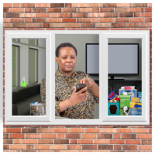 | Many of us will have felt alone or lonely during the pandemic.
 | We know that this affected some groups of people more.
   | Having support from family and friends can help us to live longer, happier lives.  It can help us to feel better after stressful situations.
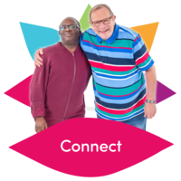 | We all need social connections to stay happy and healthy.  Social connection is feeling close to other people.
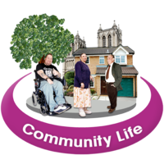 | I hope that this report helps us all think about how we can all play a part in a more connected Gloucestershire.

Report summary

 | What the COVID-19 pandemic taught us about Social Connection
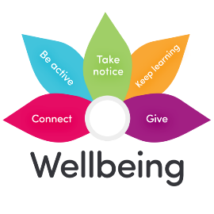 | Social connections are good for our health and wellbeing.
   | During COVID-19 people missed seeing friends and family.  People did this to protect themselves and others.
 | Friends and people provide important support.
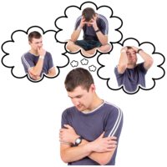 | Changes we had to make during COVID -19 made us feel lonely or worried.
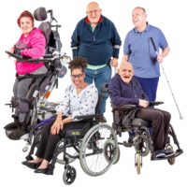 | This was worse for some groups such as those with a disability or mental health issue, children and young people, and those living alone.

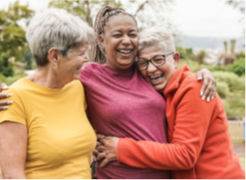 | Why are social connections so important?
Our social networks can be friends, family, people we work with or meet, neighbours or people we know online.

Having good relationships can help us to live longer, happier lives. They can also help us feel better after stressful situations.

 | Communities
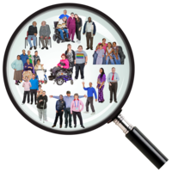  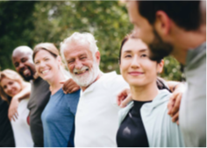 | Communities are different. They can be online, where you live, or to do with hobbies and interests.  Communities can help some people with their wellbeing.  Communities are best when people feel confident and comfortable talking and working together.

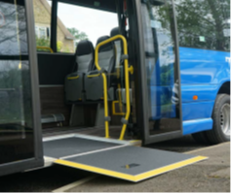 | How to access places and information
    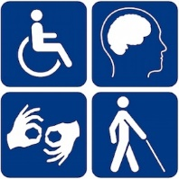   | It is difficult for some people to get about and use transport or services.  Gloucestershire is a big place and connecting to friends, family, activities, and services can be hard.  It is important to make sure that information, buildings and services can be used by as many people as possible.  We are thinking about how to make sure that everyone can use transport, buildings and get information when they need it.

 | Digital connections*  *This means connecting with people online using a phone or computer
    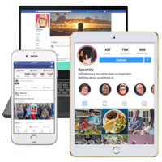   | How we live, work, and communicate with each other is changing with the internet, computers and smart phones.  Social media can help us make connections to people with the same interests as us from all over the world.  Social media can make us feel unhappy or worried or overwhelmed.  Sometimes it is good to take a break from social media.  Some people feel left out by more things being online or digital.  This happens if people don’t have a smart phone or computer or need help to use the internet.

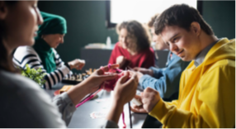 | How businesses and organisations can help
  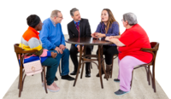     | Organisations and businesses can make us feel more connected.  Buildings can provide a space for communities and people to meet.  Businesses can give staff time off to volunteer.  They can find ways for staff to spend time together.  This helps with wellbeing.  Large organisations, like hospitals and councils, can do a lot to help improve health and wellbeing.

 | What can we do to connect?

 | - Take time each day to call or see family and friends.  - Join a local group to find other people with similar interests to you.  - Call or visit people that may be feeling lonely.  - This could be offering a neighbour a cup of tea or checking if they need help with anything.
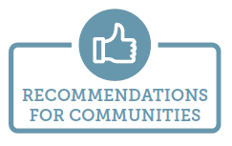 | - When planning an activity to connect people, think about how accessible it is.  - Find out who is available in the community to help.  - When bringing people together, think about if people can use the internet or have a smart phone or computer.  - Give people face-to-face contact if they need it.
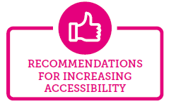  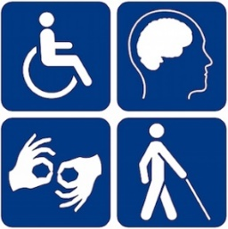 | - Involve people in planning public spaces so that they can be used by everyone.  - Think about cost, public transport and cycle routes.  - Think about how rooms and spaces in workplaces or organisations can be used to bring people together. This can be staff, service users or the public.
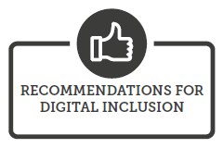 | - Make information and services accessible for all, in lots of different ways.  - Talk to children and young people, or other people that might be more vulnerable online, about how they are feeling.  - If you, or someone you know is feeling unhappy on social media take a break or tell them to take a break.  - Ask for help in turning off some messages on your phone.
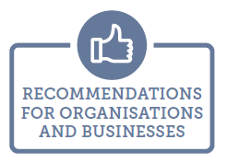 | - Tell other people that connections are good for health and wellbeing.  - Think about how you can use your spaces to help people make connections.  - This can be for staff, customers or the community.  - Even a shared tea and chat can help!  - Think how you can encourage staff to volunteer and join in with the community.

Where to go for further information

- Go Volunteer Glos - Volunteering in Gloucestershire
- The Robin - Gloucestershire’s on-demand bus service
- Community Transport - Community Transport in Gloucestershire
- Digital Divides Gloucestershire - Making social connections online fairer
- Digital Hubs - Where to get help in Gloucestershire with going online
- Keeping Young People Safe Online - How to stay safe online, for young people
- Warm Spaces - Where you can go to stay warm in Gloucestershire

