Dysphagia Training 2025

Training will be delivered FACE TO FACE

Dysphagia training courses are being delivered by GHC Trust Speech and Language Therapists.

The courses are free of charge and are aimed at Support/Care Workers working in the community with adults with a learning disability in Gloucestershire.

Some people have difficulties eating and drinking. This is called Dysphagia.

On this course you will learn how you can help to make your client’s mealtimes safe and enjoyable.

The training covers;
- The normal swallow
- What can go wrong
- Signs that someone is having difficulties eating, drinking and swallowing
- How you can help


Dates available;
Date | Time | Location
Monday 20th January | 13:30– 16:30 | Weavers Croft, Stroud
Thursday 13th March | 13:30-16:30 | Charlton Lane, Cheltenham
Monday 16th June | 13:30– 16:30 | Colliers Court, Cinderford
Monday 8th September | 13:30-16:30 | Pullman Place, Gloucester
Wednesday 5th November | 13:30-16:30 | Weavers Croft, Stroud

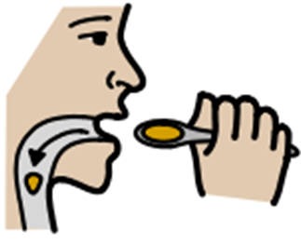

To Book your Place;
Please log onto LearnPro Community and select your preferred dates.
If you have not accessed LearnPro before please email the Proud to Learn team on proudtolearn@gloucestershire.gov.uk for the user guide, or telephone the team on 01452 324306.
A maximum of 3 places per organisation for each session are available.

