Gloucestershire County Council
Briefing Paper
May 2026 Half Term Pilot Local Offer

Context and Funding
Cabinet has approved a total allocation of £800,000 to support services that mitigate the impact of the ending of the free school meal (FSM) voucher scheme. This funding recognises the importance of maintaining support for low-income families during school holidays.
From this allocation, £150,000 has been prioritised to deliver a May half-term pilot offer. This targeted investment is intended to test a local, flexible model of provision that combines food and activities, ensuring continued support for families most in need during this transition period.
In addition to activity-based provision, the Council has also procured 4,060 food boxes through partners Dish Up and The Grace Network. These food boxes are designed to provide school meal standard provision across the half term, ensuring that families who may not access in-person provision still receive essential food support.

Purpose
This paper sets out a proposed pilot local offer for May half term 2026 in response to the termination of the free school meal (FSM) voucher scheme. The pilot ensures continued access to food provision and enriching activities for eligible families.

Background
The end of the FSM voucher scheme creates a potential gap in support for low-income families during school holidays. Gloucestershire has previously recognised, through the Holiday Activities and Food (HAF) programme, the importance of access to nutritious food and enriching activities.
This pilot mirrors key HAF principles but is not funded by the Department for Education (DfE).

Half Term Food Support Pathway
To support families to access the right help at the right time, Gloucestershire has developed a Half Term Food Support Pathway. This provides a clear and accessible framework for support available during school holidays when the Holiday Activities and Food (HAF) programme is not in operation.
The pathway consists of three key elements:
- Step 1 – Community food support
Including food banks, community fridges and locally delivered food provision.
- Step 2 – Half-term food provision with activities
Including the May half term pilot sessions outlined in this briefing, where families can access food alongside activities in a supportive environment.
- Step 3 – Urgent or crisis support
Including access to emergency food, financial advice and wider support via the Crisis and Resilience Fund.
This pathway is supported through the Virtual Family Hub, which provides additional signposting and ensures families can access a wider network of help. Key resources include:
- Feeding Gloucestershire Community Food Map (1)
Supporting families to locate food banks, community fridges and other food provision locally:
https://familyhubs.gloucestershire.gov.uk/feeding-gloucestershire-home

- Family Hubs information pages (2)
Providing details of local Family Hub locations, services and support available to families:
https://familyhubs.gloucestershire.gov.uk/family-hubs

- Gloucestershire Family Support Guide (3)
Other Support and Resources for HAF

May Half term 2026 Pilot Offer
The offer provides place-based provision across Gloucestershire, combining family-focused activities with a food offer at each session, alongside the distribution of food boxes to maximise reach and accessibility.

Planned Provision by District
District | Locations | Offer Type
Cotswolds | Moreton-in-Marsh; Bourton-on-the-Water | “Go Wild” Family Fundays
Cheltenham | St Pauls; The Moors; Oakley; Springbank; Town Centre | Forest school activities
Forest of Dean | Rachel Shilston Studio, Lydney | Family Arts and Crafts
Gloucester District | Lanett in Linden; Sebert Street Park in Kingsholm | Pop-up activity days
Stroud | Victory Park | Pop-up activity days
Tewkesbury | Tewkesbury Youth Hub; Brockworth Youth Hub | Family Fun Days

Communications Plan
Channel | Audience | Status | Date
CYP Screens in offices | Social Care | Scheduled | 19/05/2026
Heads up | Heads of schools | Scheduled | 19/05/2026
Local Offer | SEND Families | Scheduled | 19/05/2026
Email | May HAF Providers | Scheduled | 19/05/2026
GCC social media | Public | Scheduled | 19/05/2026
Virtual Family Hub Message | VFH users / live chat and phone lines switched on to provide assistance | Scheduled | 19/05/2026
Newsletter | HAF Subscribers | Drafted/scheduled | 19/05/2026
Email | Steering group members | Scheduled | 19/05/2026
Democratic Services | District and county councillors | Scheduled | 20/05/2026

Finding Food Support During the half-term holidays (4)
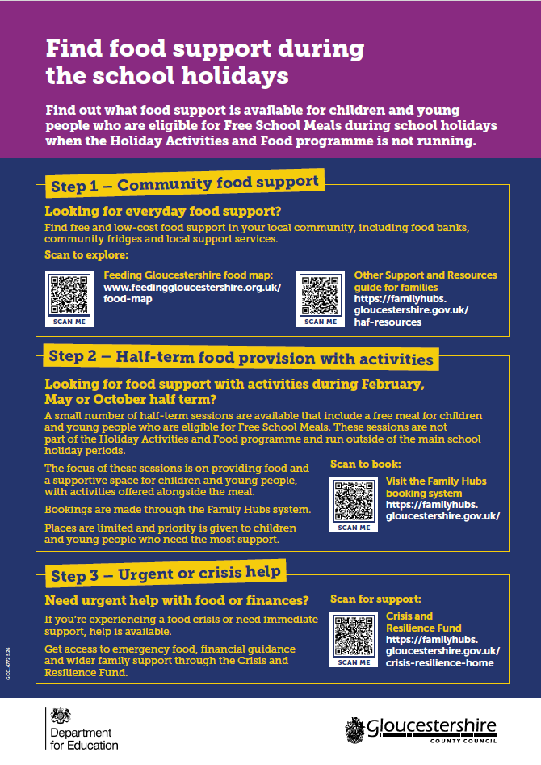

Rationale and Importance
The withdrawal of FSM vouchers increases the risk of holiday hunger. This combined food and activity offer reduces food insecurity while supporting children’s wellbeing, social interaction, and development.
The inclusion of 4,060 food boxes ensures wider reach, particularly for families unable to attend sessions, strengthening the overall impact of the programme.

Risks of Not Providing the Offer
Without this pilot, families may face increased hardship, reduced access to food, and greater social isolation. This may lead to additional pressure on wider public services.

Pilot Approach and Future Development
This programme is a test-and-learn pilot. If successful, the Council will consider extending provision to October 2026 and February 2027 half terms.

Conclusion
This pilot represents a proactive response to the end of FSM vouchers, combining activity provision with direct food support to ensure families continue to receive essential support during school holidays.

Appendix 1 – Feeding Gloucestershire Community Food Map
The Feeding Gloucestershire Community Food Map provides a comprehensive, accessible directory of food support available across the county. It is designed to help families quickly identify local provision and access support within their community.
Purpose
The map supports families by:
- Identifying locations of food banks, community fridges and food pantries
- Highlighting free and low-cost food provision
- Improving awareness of locally available support networks
Key Features
- Interactive, user-friendly online platform
- Regularly updated to reflect current provision
- Covers both statutory and voluntary/community sector services
- Enables location-based searching to find support nearby
Access
Families and professionals can access the Community Food Map via the Virtual Family Hub:
https://familyhubs.gloucestershire.gov.uk/feeding-gloucestershire-home

Role within the Pathway
The Community Food Map supports Step 1 – Community Food Support within the Half Term Food Support Pathway, encouraging early access to local provision and reducing reliance on crisis services.

Appendix 2 – Family Hubs Information Pages
The Family Hubs Information Pages provide a central source of information about support available to children, young people and families across Gloucestershire.
Purpose
The pages support families by:
- Providing information on local Family Hub locations
- Outlining available services, activities and support offers
- Enabling families to understand how to access early help and wider services
Key Features
- Overview of Family Hub services across Gloucestershire
- Information on health, education, parenting and wellbeing support
- Access to booking systems for activities and targeted provision
- Clear routes for accessing additional help where needed
Access
Families and professionals can access information via:
https://familyhubs.gloucestershire.gov.uk/family-hubs

Role within the Pathway
The Family Hubs platform underpins the entire Food Support Pathway, acting as a central navigation tool that connects families to:
- Community food provision
- Half-term activity sessions
- Crisis and specialist support services

Appendix 3 – Gloucestershire Family Support Guide (Spring 2026)
The Gloucestershire Family Support Guide (Spring 2026) provides a comprehensive overview of the services, support and resources available to families across the county.
Purpose
The guide aims to:
- Offer a single, accessible source of information for families
- Improve awareness of available services and entitlements
- Support families to access the right help at the right time
Key Content
The guide includes information on:
- Food and financial support
- Health and wellbeing services
- Parenting and family support
- Education and early years provision
- Community-based services and activities
Access
The guide is available digitally and can be accessed via:
Other Support and Resources for HAF
Role within the Pathway
The Family Support Guide complements the Virtual Family Hub and Food Support Pathway by providing broader context and additional signposting, ensuring families are aware of the full range of support services available beyond food provision.

Appendix 4 – Food Support Pathway (Poster Summary)
This appendix provides a summary of the Half Term Food Support Pathway poster, which has been developed to support families in accessing food and wider assistance during school holiday periods when the Holiday Activities and Food (HAF) programme is not running.
The poster presents a simple, step-by-step guide to help families identify the most appropriate support available to them.

Overview of the Pathway Structure
The poster outlines a three-step model for accessing food support:
Step 1 – Community Food Support
Families are encouraged to first explore everyday food support within their local community, including:
- Food banks
- Community fridges
- Local food support services
This provision is designed to be widely accessible and supports families with ongoing or lower-level need.

Step 2 – Half-Term Food Provision with Activities
The poster highlights that a small number of half-term sessions are available which include:
- A free meal for children and young people eligible for Free School Meals
- Activities alongside the meal
- A supportive and safe environment
These sessions:
- Are not part of the main HAF programme
- Run during February, May, and October half terms
- Have limited places, with priority given to families most in need
- Are booked through the Family Hubs system
The focus of this provision is on combining food with supportive engagement opportunities.

Step 3 – Urgent or Crisis Support
For families experiencing immediate need, the poster signposts access to:
- Emergency food provision
- Financial guidance
- Wider support via the Crisis and Resilience Fund
This ensures that families in crisis are able to access rapid and appropriate assistance.

Additional Support and Resources Highlighted
The poster signposts families to further sources of information and support, including:
- Family Hubs website and booking system
Providing access to services, support, and activity bookings
- Feeding Gloucestershire food map
Helping families identify local food provision and community support
- Crisis and Resilience Fund
Supporting families facing urgent financial or food insecurity
- HAF resources and family support guidance
Offering wider information about support available across Gloucestershire

Accessibility and Communication Approach
The poster uses:
- A clear visual structure
- Simple step-based messaging
- QR codes and web links for direct access to support
This enables families and professionals to quickly understand:
- What support is available
- How to access it
- Where to go for further help

Purpose of the Poster
The Food Support Pathway poster has been developed to:
- Provide clear and consistent messaging across Gloucestershire
- Support self-service access to food and family support
- Ensure families are aware of both universal and targeted provision
- Reduce reliance on crisis services through early signposting and intervention

