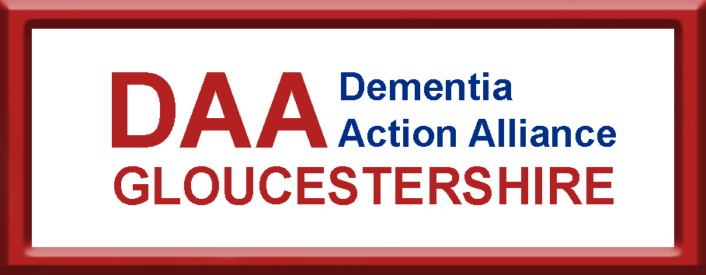

Expressions of Interest Form

Our commitment:
- By completing this action plan we are showing an interest in joining the impending Gloucestershire Dementia Action Alliance which will be signed up to the National Dementia Declaration, www.dementiaaction.org.uk/nationaldementiadeclaration

- We commit to working towards the actions below

Organisation / Name _________________________________________________

Contact Details

Contact name / role
Address

Phone
Email
Website

Can we share your contact details?
Yes ☐ No ☐ with other Dementia Action Alliance members
Yes ☐ No ☐ within the community

Organisation type - please tick the relevant words that best reflect you/your organisation

☐ Arts
☐ Care
☐ Communication
☐ Emergency Services
☐ Finance
☐ Health
☐ Hospitality
☐ Individual
☐ Medical
☐ Membership
☐ Pharmaceutical
☐ Public sector
☐ Recreation
☐ Religious
☐ Research
☐ Retail
☐ Transport
☐ Utility
☐ Voluntary
☐ Other …………….

…………………………

Our Action Plan is:
Please complete at least 3 actions - you can add more if required.
Action 1: Title:

What we/I are going to do:

Action 2: Title:

What we/I are going to do:

Action 3: Title:

What we/I are going to do:

Are there any challenges to delivering these outcomes for you or your organisation/group/business?

How can you overcome these challenges?

Please do not hesitate to contact us for information or support

Please email your organisation logo (if possible by e-mail in .jpg format) & return this form to:
Lena Maller, Community Engagement Officer, Forest of Dean District Council
lena.maller@publicagroup.uk

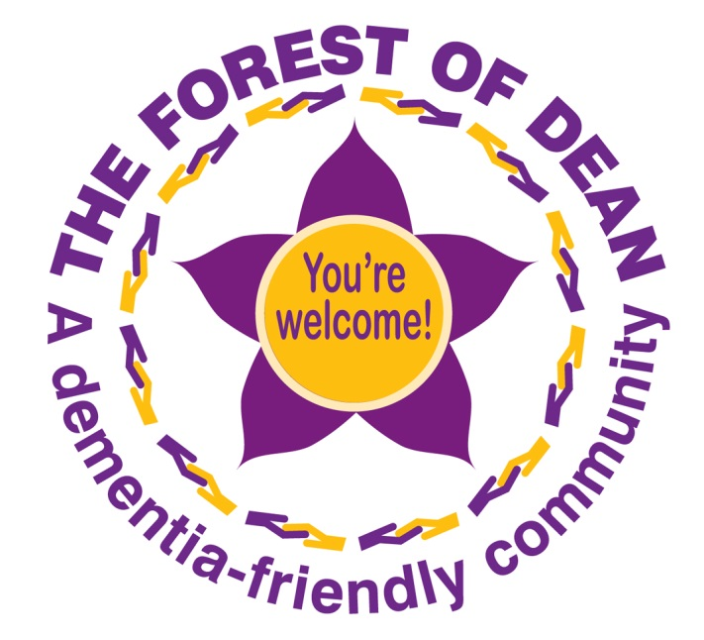
Thank you very much for showing an interest in The Gloucester Dementia Action Alliance.

